Outlook Economics
Structural and Macroeconomic Responses to the Rise of Asia and the Mining Boom
AUS-M Model Simulations

Report prepared for the Reserve Bank of Australia
Authors:
Peter Downes
Kevin Hanslow
Peter Tulip October 2013
12
Outlook Economics is an Australian based economic consultancy, established in 2009, that specializes in economic modelling, policy analysis and forecasting. We provide professional, independent and timely analysis of the economic outlook, events and policies. Outlook Economics is independent and non-partisan – funded only by subscriptions to its models and forecasts, and by commissioned research and reports.

© Outlook Economics 2013
This work is copyright. Persons wishing to reproduce this material should contact Outlook Economics at the following address.
Canberra
Outlook Economics
11 Bailey Place,
Yarralumla,
Canberra ACT 2600
Telephone +61 2 6282 9747
Email info@OutlookEconomics.com
Website www.OutlookEconomics.com

Disclaimer
While Outlook Economics endeavours to provide reliable analysis and believes the material it presents is accurate, it will not be liable for any party acting on such information.
Contents:
Response to a once in a century mining boom 5
Modelling the mining boom 8
The counterfactual simulation 9
Modifications to the Model 12
The decline in mining capital productivity 13
Adjustment to capital goods imports 14
Net migration and the exchange rate 18
Macroeconomic responses 19
The exchange rate 20
Activity and Unemployment 21
The dwelling sector 23
Consumption, saving and the current account balance 24
Foreign ownership and income outflows 26
Overall response 29
Consumption details 32
Business investment 34
Export details 36
Supply side responses - industry and import details 38
Employment by industry 43
Changing macroeconomic responses 45
Conclusion 47
References 50
Appendixes 53
Appendix A: Impacts of a mining commodity price shock: AUS-M and Monash 55
Appendix 2: Description of AUS-M 60
Supply and Demand in AUS-M 60
Appendix C: Limitations to the model based analysis. 68
Long-run or equilibrium 68
Short to medium run adjustment paths 69

Boxes, charts and tables
1 World Industrial Production: Actual and Counterfactual 10
2 Mineral Commodity Prices: Actual and Counterfactual 11
3 Mining Investment: Actual and Counterfactual 12
4 Mining Operations 2006-07: Summary Details 13
5 Mining Investment: Actual and Counterfactual 14
6 Mining Investment by Asset 15
7 Capital Goods Import Equation Residual 16
8a Capital goods imports as a share of GDP: Actual and Counterfactual 17
8b Construction output as a share of GDP: Actual and Counterfactual 17
9 Net Migration: Actual and Counterfactual 19
10 Real Exchange Rate: Actual and Counterfactual 21
11 Interest Rates and Inflation: Actual and Counterfactual 22
12 Unemployment: Actual and Counterfactual 22
13 Rental vacancies and Rental Prices: Actual and Counterfactual 23
14 Dwelling Q Ratio and Investment: Actual and Counterfactual 24
15 Private Savings: Actual and Counterfactual 25
16 Current Account Balance: Actual and Counterfactual 25
17 Foreign Equity Liabilities and Assets 28
18 Net Rates of Return on Capital – Selected Industries 28
19 GDP and National Disposable Income: Deviation from Baseline 29
20 Household Income and Consumption: Deviation from Baseline 30
21 Consumption per capita – Actual and Counterfactual 31
22 Underlying labour productivity in the non-commodity sector 32
23a Consumer Prices – Selected Components: Deviation from Baseline 33
23b Household Consumption – Selected Components: 33
24 Business Investment – Selected Industries – Deviation from Baseline 34
25 Business investment by asset – deviation from baseline 35
26a Mining Manufacturing and Service Exports: Actual and Counterfactual 37
26b Manufacturing and Service Exports: Actual and Counterfactual 37
27 Manufacturing Output: Demand and Relative Prices 39
28 Manufacturing Net Rate of Return: Actual and Counterfactual 40
29 Consumer Good Imports: Demand and Relative Price Effects 41
30a Industry Output Prices: Deviation from Baseline 42
30b Industry Output: Deviation from Baseline 42
31 Output Shares in GDP: Actual and Counterfactual: Selected Industries 43
32 Bulk Commodity and Metal Exports: Per Cent of GDP 46
A1 Mining Commodity Price Shock Results: AUS-M and MMRF 58
A2 Supply and demand variables in AUS-M 62
A3 Stylised representation of the input-output core of the AUS-M model 63

Response to a once in a century mining boom
In 2012 Australia’s GDP per capita measured at market exchange rates was the fifth highest in the world, only surpassed by oil rich Qatar and Norway, and the financially wealthy European states of Luxembourg and Switzerland. Australia’s per capita GDP was 36 per cent higher than that of the United States and almost double (76 per cent higher) that of the United Kingdom. Eleven years earlier Australia ranked 25th in the world. Australia’s comparative level was almost half that of the United States and three quarters that of the United Kingdom.
The movement up the ranks of course was mainly due to the appreciation of the exchange rate. But the value of the exchange rate, at least in theory should reflect available information about the future course of the economy. In 2001 the Australian dollar languished at around 50 US cents and momentarily dropped to 48 US cents. At the time the view was that Australia was a high labour cost economy, with a small and declining manufacturing base, poorly integrated into global production chains, underweight in new information technology based industry and overweight in ‘old economy’ industries like mining and agriculture, where returns had been low for more than a decade. China was then a small developing economy with a vast, poorly educated rural labour force. It ranked poorly on international measures of corruption and governance, had a history of political instability and was dominated by large inefficient state owned enterprises.
The story of the transformation of Australia’s fortunes over the last decade is inextricably linked to the rise of Asia and changed perceptions about the long term prospects for countries such as China, India and Indonesia. Developing country shares of manufacturing production and of global savings and investment have now passed fifty per cent. The structural changes that are occurring in the global economy are consequently quite profound, and form the backdrop to this study. They have a number of implications for how the Australian economy is responding to what is a unique historical change.
Expectations are important
The first relates to expectations. The large change in outlook and expectations noted above is an important but intangible aspect of the economic response to rising commodity prices and improving prospects for the mining industry. It is one of a series of complicating factors that needs to be considered in modelling the effect of the mining boom on the economy. Responses to a shock depend on whether businesses and households expect them to be temporary or permanent. From the scale of the investment response it appears that business believe that the shock involves a structural shift that will persist. The appreciation of the exchange rate through 2005 to 2011 suggests a similar view exists in the financial market. At the same time the increase in household saving suggests that in part households are viewing the gains as temporary. The timing of these different responses have implications for the particular path the economy has taken in response to the shock and to the modelling results discussed below.
A less stable global environment
Moreover, the rise of China, India and other developing countries has changed how the global economy works. The decade and a half of relatively stable global growth and low commodity prices following the collapse of the Soviet Union was bought to an end by the spike in oil and commodity prices in 2007-08 and the global financial crisis the following year. With China and India and other developing countries continuing to press on commodity markets and accounting for a higher share of GDP, the global economy is likely to less stable / less certain than in the past. Australia is increasingly exposed to this instability because of the mining boom and rising commodity exports, and this instability has important implications for our policy institutions.
The source of the shock matters
And it is not only the structural changes in the international economy, and expectations about future changes that are important. As Jaaskela and Smith (2011) have demonstrated: how a terms of trade shock effects the economy depends on the source of the shock. That is also a theme in the earlier results from the GCubed model reported in McKibbin and Cagliarini (2009). The rise in mining investment and its impacts on the Australian economy have some parallels with the discovery of North Sea oil and its impact on the UK economy in the 1970s and 1980s. As Bean (1987) notes the discovery of oil in the 1970s and the consequent increase in investment had different effects to the increase in oil prices following the second oil price shock in 1979-80. In Bean’s modelling both raise the exchange rate, but in the former case the expansion of demand for manufactured goods due to higher investment more than offsets the impacts of the exchange rate on manufacturing. In the latter case (higher prices) the impact is more on the exchange rate and less on investment and manufacturers are worse off.
And other things are happening
Moreover, higher commodity prices are only one of a series of factors that are shaping economic outcomes. World interest rates have fallen to very low levels. The price of the investment goods and the consumer durables continue to fall. At the same time there have been a range of domestic developments driving structural change in the economy. The mining boom for example has arguably disguised a fall in productivity growth and hence incomes that would otherwise have been much more apparent. It has boosted some industries such as construction and accelerated the decline in others such as manufacturing.
But by how much? How would things have looked without the rise of Asia, the commodity price boom and the associated surge in national income and the exchange rate? How much of the change that is occurring is due to the mining boom and how much to other factors? Would unemployment have fallen to such low levels in 2007-08 in the absence of the boom? Would Australia have continued to grow and emerged from the global financial crisis relatively unscathed?
And, what will happen if commodity prices fall and the mining investment boom turns into a mining investment bust? A number of recent authors have argued that Australia faces a protracted period of adjustment as commodity prices and mining investment return to more normal levels over the next few years.
The aim of this paper is to build on previous work on the mining boom by the RBA and others by using a fully articulated macro-econometric model to throw further light on the transitional and long-run impacts on the economy. The first section below provides a description of the shocks applied to the model. The second section describes some of the special adjustments made to the model to accommodate those shocks. This is followed by a section discussing some of the macroeconomic outcomes, and then by a section looking at the outcomes by detail starting with the demand side of the economy (expenditure and exports) and ending with supply (industry and imports). Appendix A provides a cross check on the long run results from the macro model in the form of a comparison with simulation results from the Monash MMRF model. Appendix B provides a description of the model, and Appendix C provides a brief discussion of the main limitations of the analysis.

Modelling the mining boom
To gauge the impacts of the mining boom requires a comparison to a counter-factual. To construct such a counterfactual we employ the AUS-M model of the Australian economy – a reasonably well-established macro-econometric model estimated on the basis of historical time series data. AUS-M can be broadly described as having a new-Keynesian style demand-driven short run, around a CGE style supply-driven long run. Information from input-output tables is used to systematically link demand and supply. (Appendix B provides a more detailed description of the model.)
The construction of a historical counterfactual is complicated, and involves a number of judgements about intangible factors as discussed above. There are consequently a large number of qualifications to the results. The point is not to focus on the precise numbers but rather on the broad picture that emerges in terms of the ultimate structural changes to the economy, and the process of adjustment that yields those changes.
The first thing that becomes obvious is the complexity of disentangling the inter-related set of developments that led to the mining boom. It turns out that the increase in commodity prices that has driven the lift in the terms of trade is much greater than can be explained by the increase in demand driven by the rise of Asia. And the lift in investment turns out to be more than can be explained by the lift in the terms of trade. As discussed above the source of the shock is important, and Bean’s results seem particularly pertinent here with the effects of a shift in investment (a resources boom) being different to a boost driven by a rise in prices (a terms of trade boom).

The counterfactual simulation
The objective of the simulation was to strip out the mining boom from history. To do so turned out to require not one shock but a series of shocks (and other adjustments). The historical counterfactual consequently proceeded in three main stages:
- The first was to lower world growth and world industrial production from mid-2002 onwards. This took the form of simply extending the trend growth of global industrial production and other world variables from 2002 onwards (Chart 1). In doing so only the trend growth rate was changed not the variation around the trend – so for example the GFC still occurs. (Note also that the slower growth impacts on agricultural, manufacturing and service exports as well as mining exports. Given the role of surging demand from China etc. in driving the pick-up in commodity prices it seemed unrealistic to run such a large shock without also lowering world growth. A simulation where only commodity prices are shocked is discussed in Appendix A.)
1 World Industrial Production: Actual and Counterfactual
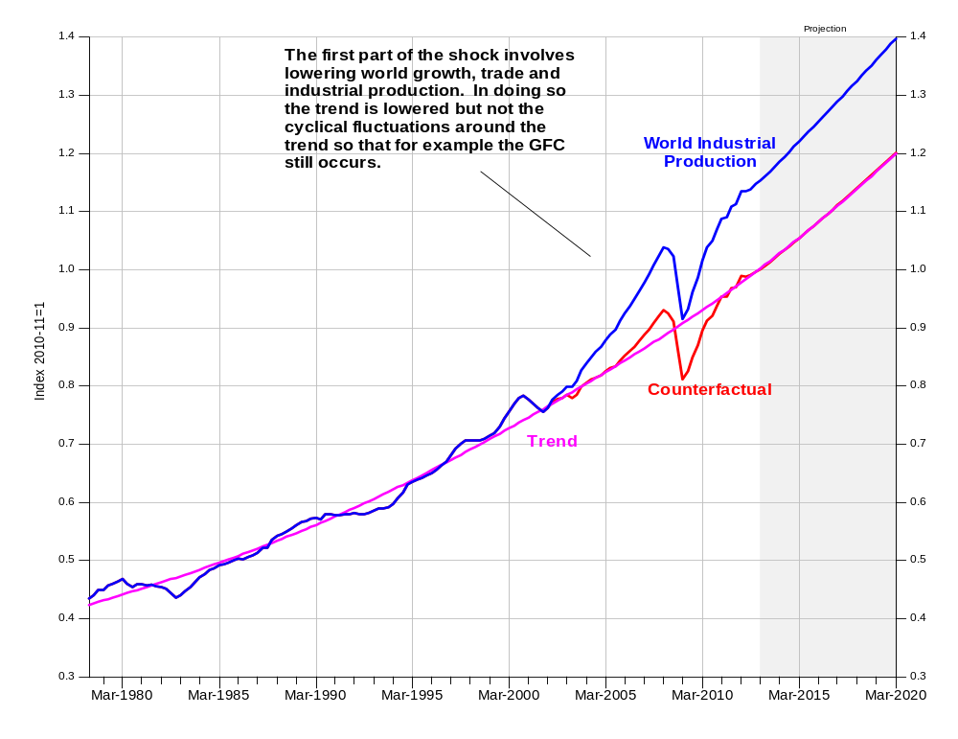
Notes: Trends in world GDP, industrial production and trade estimated with a HP filter (lamda=20,000) of the natural log of the variable for the period 1978:1 2000:2 and then extrapolated. Shocked series adjusted from 2002:2 onwards.
Data source: OECD Main Economic Indicators, EMED Emerging Asia Database, World Bank Economic Monitor, CPB Trade Monitor, author estimates.
- The second was to lower commodity prices below what the lower world growth would imply (Chart 2). Even after returning global growth to trend there was still a significant pick up in commodity prices. Without wanting to read too much into the result, this suggests that there were supply side as well as demand side elements to the surge in prices. It may be for example that low prices for commodities such as iron ore during the 1980s and 1990s led to a reduction in exploration activity and investment, which, given the long planning horizons required for greenfield developments, led to a short-fall as demand picked up. Similarly increased environmental regulation, or the gradual depletion of high grade deposits close to transport links, may have led to an inevitable tightening of supply in the first decade of this century.
2 Mineral Commodity Prices: Actual and Counterfactual
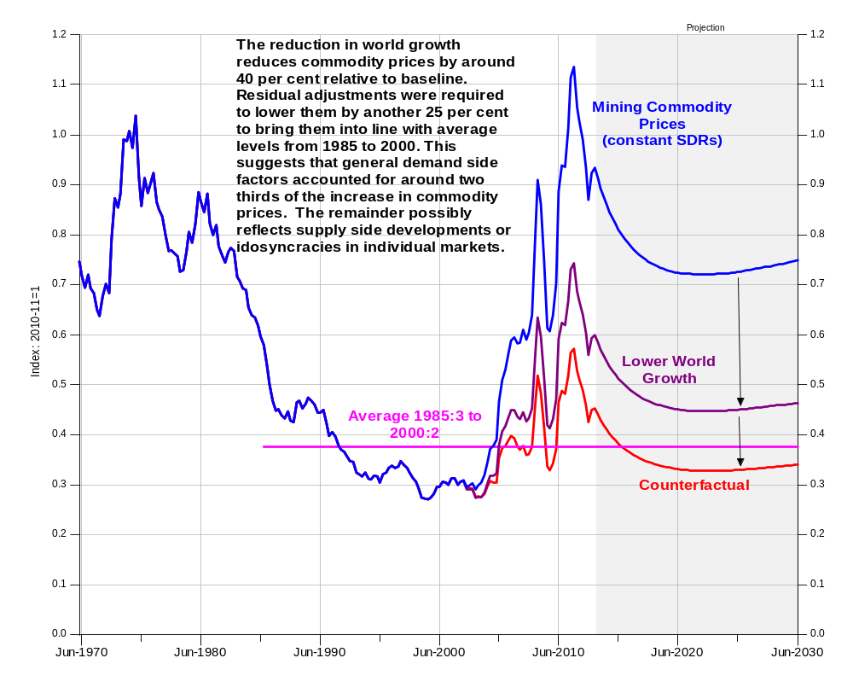
Notes: RBA non-rural commodity price index in SDRs divided by G7 consumer prices
Data source: OECD Economic Outlook Database, RBA Bulletin, BREE Resource Statistics, IMF IFS Database, author calculations and AUS-M model simulation.
- The third and final component was to lower mining investment beyond the response to lower commodity prices (achieved by setting residuals in the mining investment equations to zero). As discussed above the mining boom has aspects of a response to price and also of a response to resource discovery. In particular the development of horizontal drilling and seam fracturing or fracking technology has allowed the exploitation of coal seam and shale gas reserves that previously were difficult if not impossible to tap. At the same time a combination of factors in Asian energy markets, particularly concerns over energy security, pollution and green-house gas emissions has led to a demand for the sort of long-term contracts which have allowed the commitments to be made for the projects to be built. The Bureau of Resource and Energy Economics (BREE) major project listing indicate that $205 billion (77 per cent) of the $268 billion worth of projects currently committed or under construction are in the LNG, Gas or Petroleum sector, with $62 billion of this in Queensland involving mainly CSG. To some extent this exaggerates the share of LNG and CSG because of the size and timeframes of the projects. Smaller projects with shorter horizons require less in the way of pre-commitment and therefore will not feature as prominently in the committed listing. (LNG, Gas and Petroleum account for only $72 billion or 31 per cent of the $232 billion of projects currently at the feasibility stage. ) But even so the model results suggest that for mining investment to reach such extraordinary heights reflected not only the response to higher prices and lower interest rates , but also technical developments that allowed the exploitation of a new resource and a shift in expectations that gave mining companies the confidence to commit to very large projects.
3 Mining Investment: Actual and Counterfactual
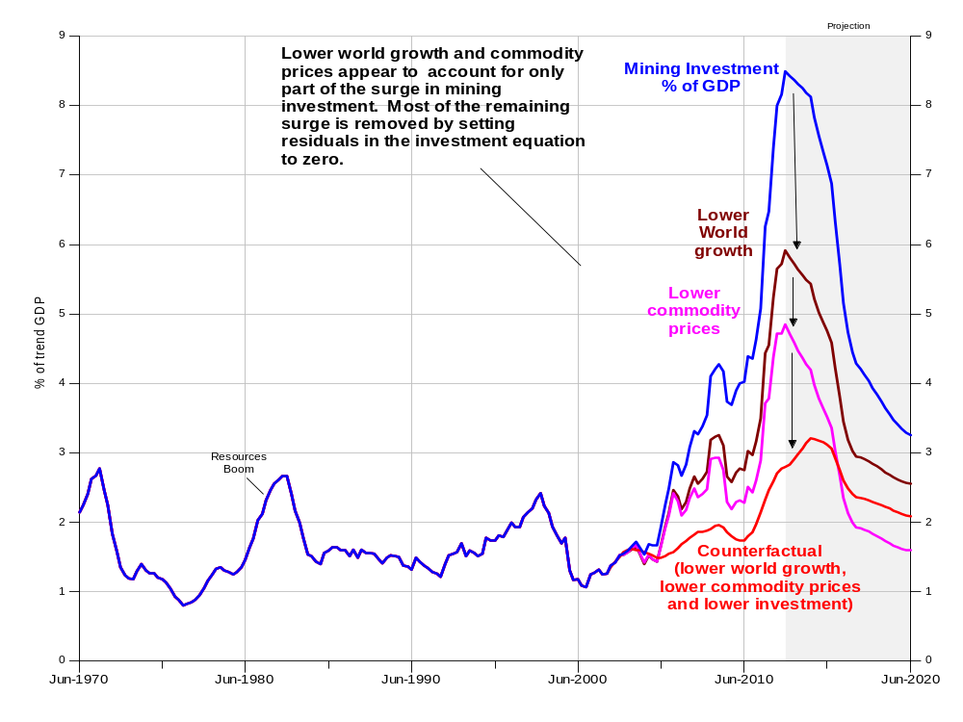
Notes: Series show mining investment (IMIN) as a percentage of trend GDP.
Data source: ABS Cat No 5206.0, 5204.0 5625.0 and 8214.0 author estimates AUS-M model database and simulations.

Modifications to the Model
The shocks represented in Charts 1 to 3 are so large, and the size of the structural transformation being induced by the mining boom so pervasive, that they necessitate changes to the model itself. (Normally running a shock around a baseline the assumption is that the model itself is invariant to the shock.) In this case there are a number of changes that needed to be considered.

The decline in mining capital productivity
One large adjustment (and this is also true for the MMRF simulations) is to capital productivity in the mining sector to account for: (a) changes in the average quality of resources being exploited as prices rise; and (b) compositional changes within the sector with the rise of LNG and iron ore production which in turn are more capital intensive than other sectors with very low wage shares (Table 4) and hence have lower output to capital ratios. (Oil and gas extraction also has a higher ratio of value added to sales, and hence has less interaction with / less requirement for inputs from other industries in production.)
4 Mining Operations 2006-07: Summary Details
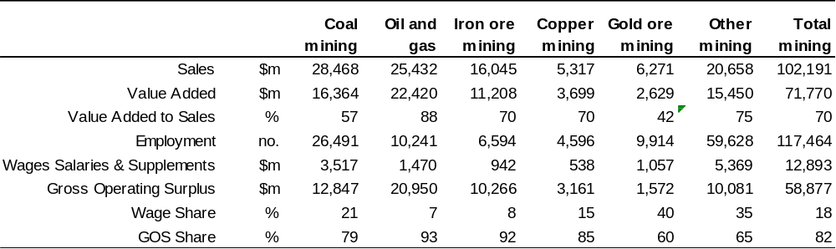
Notes: Gross operating surplus derived as value added less wages salaries and supplements.
Data source: ABS Cat No 8415.0, author estimates
The models estimate of underlying capital productivity in the mining sector (abstracting from substitution effects and lags between investment and production) is shown in Chart 5 in comparison with actual productivity levels, (chain linked value added over the net capital stock at replacement cost). As with the surge in investment the model accounts for some part of the decline in actual productivity due to substitution towards capital as commodity prices rise and interest rates fall. But a significant portion is captured by the stochastic trend. In the projections this is assumed to continue to decline to reconcile the models mining output and export forecasts with those from the Bureau of Resource and Energy Economics. In the counterfactual, as the surge in prices and in iron ore and LNG investment does not occur, we assume that there is no significant decline in underlying capital productivity. (Measured capital productivity still declines because of substitution effects due to low interest rates and the small rise in commodity prices.)
5 Mining Capital Productivity: Actual and Counterfactual
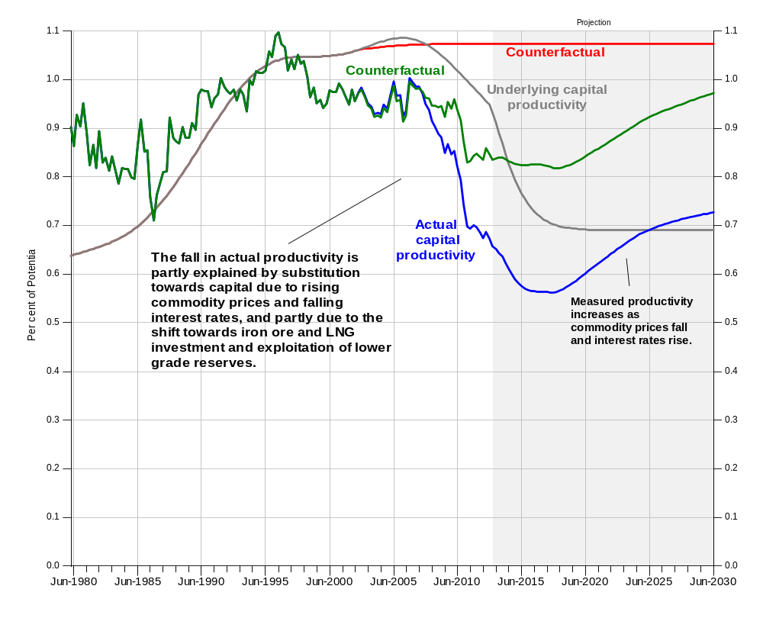
Notes: Capital productivity is measured as constant price value added (GMIN) over the net capital stock (KMIN) lagged 8 quarters. Underlying capital productivity is a stochastic trend derived in the joint estimation of the employment and investment equations, (with the joint estimation involving common parameters derived from the production function in the long run component of each equation. The variable controls for substitution effects and lags between investment and production..
Data source: ABS Cat No 5206.0, 5204.0 5625.0, author estimates and AUS-M model database and simulations.

Adjustment to capital goods imports
The increase in mining capital intensity, and the exploitation of less accessible reserves has also led to an increase in mining construction relative to equipment investment (Chart 6). (The platforms and ports and rail investment by mining companies count as construction investment.)
6 Mining Investment by Asset
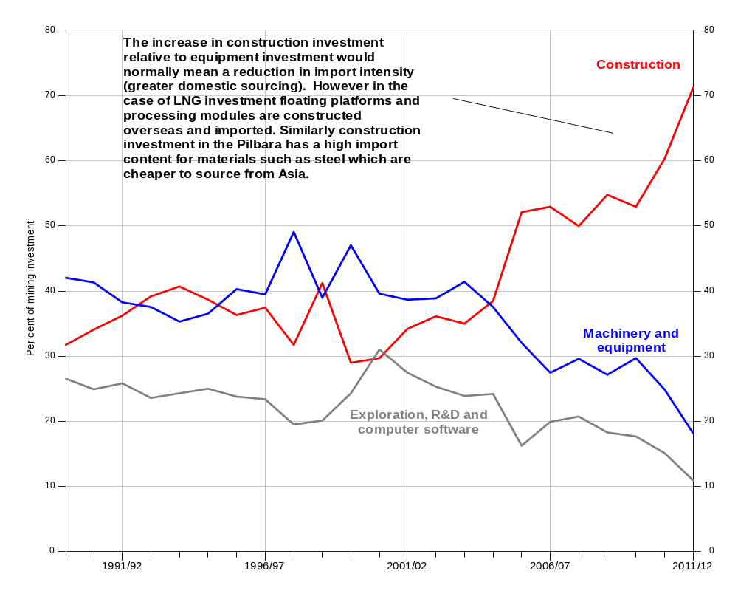
Notes: Investment data is at current prices.
Data source: ABS Cat No 5206.0, 5204.0 5625.0, author estimates and AUS-M model database and simulations.
The increase in the share of construction investment would normally mean a reduction in the import intensity of mining investment, as equipment is typically sourced overseas and construction done locally. However evidence derived by examination of company level information by Connolly and Osmond indicates that a high proportion of the construction investment in mining is likely to leak into imports as floating platforms and LNG modules are bought in from overseas, and as materials used in construction are increasingly sourced from Asia. (They note though that the site preparation work that occurs early in the LNG projects is likely to be domestically sourced.) Gregory and Sheehan similarly estimate that the import content of mining investment will rise to around 45 per cent by 2014-15 and thereafter decline.
There appears to be some evidence to support this contention in the model’s equation residuals for capital goods imports and construction output (Chart 7).
7 Capital Goods Import Equation Residual
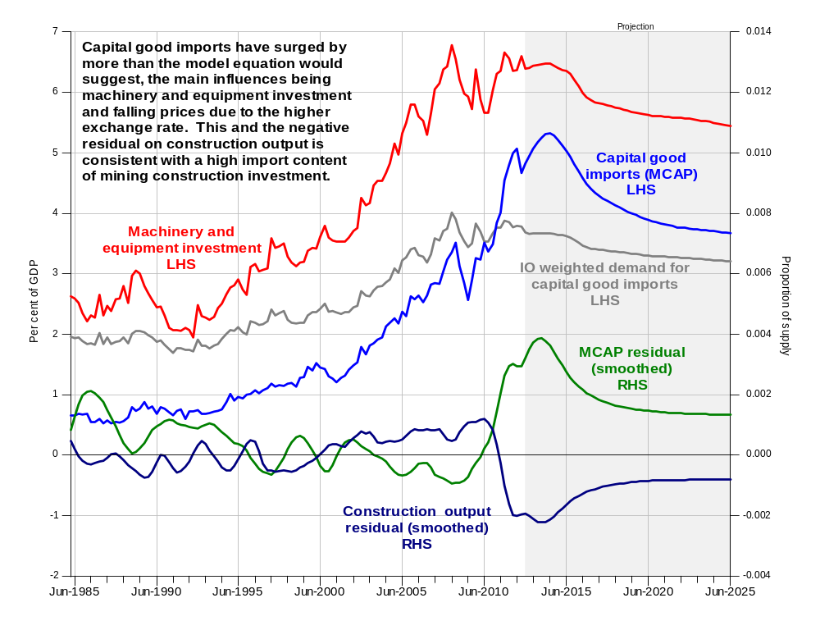
Notes: Machinery and equipment investment is adjusted for second hand asset sales. Residuals are smoothed for charting purposes using a HP filter (lamda=10). Equation residuals are expressed as a proportion of non-commodity supply (GDP plus imports less agricultural and mining output). As the system fully allocates demand to supply, a positive residual on one supply item necessarily shows up as a negative on others.
Data source: ABS Cat No 5204.0 5302.0, author estimates and AUS-M model database and simulations.
Given that in the counterfactual the surge in LNG and iron ore project investment does not occur, there is no reason to expect the import content of mining investment to increase, and so for consistency the residuals both on capital goods imports need to be largely removed. The impact of this is shown in Charts 8 and 9 below.

8a Capital goods imports as a percentage of GDP: Actual and Counterfactual
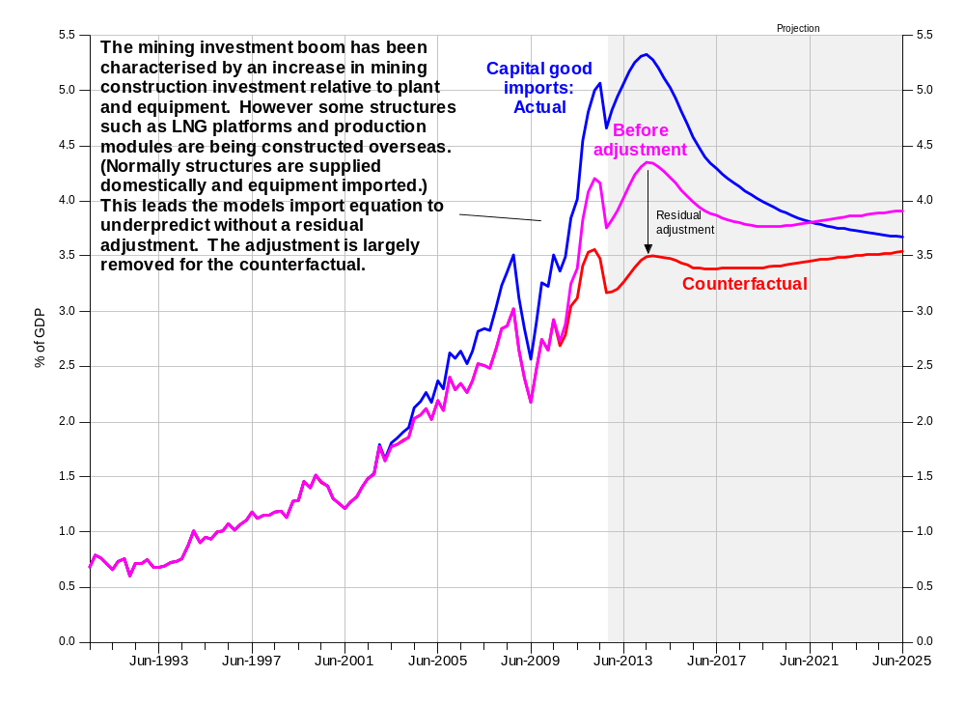
Notes: Series show capital goods imports as a percentage of GDP.
Data source: ABS Cat No 5206.0, 5204.0 5625.0 and 8214.0 author estimates AUS-M model database and simulations.
8b Construction output as a percentage of GDP: Actual and Counterfactual
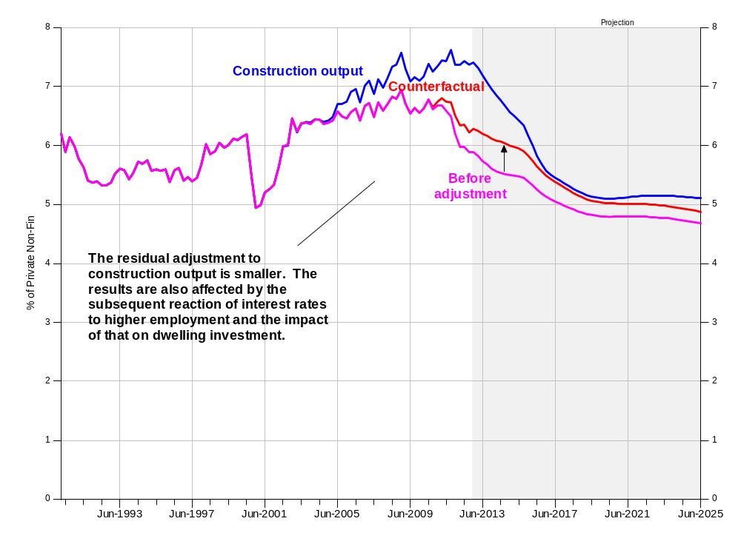
Notes: Series show construction output (constant price value added) as a percentage of GDP.
Data source: ABS Cat No 5206.0, 5204.0, author estimates and AUS-M model database and simulations.
As can be seen in Charts 8 and 9, the adjustment subtracts around ¾ of a percentage point as a percentage of GDP from capital goods imports by 2014-15, and adds about ½ a per cent to construction. The lower level of capital goods imports in the counterfactual at face value offsets about 35 per cent of the fall in mining investment. But at the same time investment in other industries (which as a rule are more import intensive) is higher. Taking the latter point into account the results probably represent an import offset of around 40 per cent to the drop in mining investment, which would be broadly consistent with the results in the studies mentioned earlier.

Net migration and the exchange rate
The period of the mining boom has also been associated with a period of higher net migration which is probably partly attributable to its effects. There are direct effects via demand for skilled workers in the mining sector and hence for 457 visa holders. But probably more important are the indirect effects via a high exchange rate and lower unemployment, which makes Australia a more attractive place to work for those overseas, and travelling overseas to work less attractive for those in Australia. (In addition the official migration programme has also been pro-cyclical in the past, and probably would have been more restrictive in a less buoyant environment.)
Consequently in the absence of the mining boom net migration would likely have been lower. So for the purpose of the simulation the net migration rate is lowered (Chart 9) and that then feeds through to the other demographic variables. The initial impact of lowering net migration is to lower the unemployment rate. Lower unemployment leads to higher wage increases than otherwise, higher inflation, and higher interest rates which lead to lower demand which eventually reduces employment to a level consistent with the lower population level. So in the medium term a lower migration assumption is associated with lower employment and lower GDP than otherwise.
9 Net Migration: Actual and Counterfactual
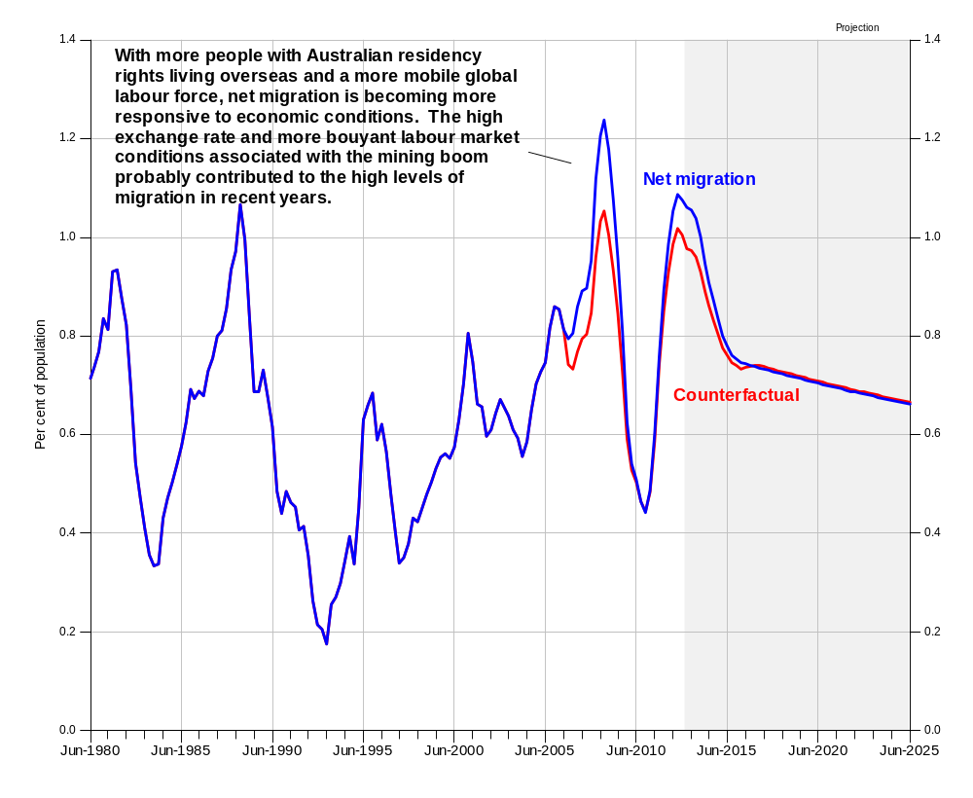
Notes: Published net migration is adjusted to be consistent with the ABS estimate of the resident population assuming birth and death data is accurate. Series is smoothed and expressed as a percentage of the resident population, quarterly data at annual ratse Projections assume that net migration returns to levels consistent with ABS long-run medium population projections.
Data source: ABS Cat No 5206.0, 5204.0, author estimates and AUS-M model database and simulations.
There are a series of other adjustments such as to labour productivity in construction to account for the compositional shift in the sector, but the overall impacts on the model results of these are relatively small.

Macroeconomic responses
The macroeconomic responses of the model to the combined shock (lower world growth, lower commodity prices and lower investment) are similar in many ways to the stylised responses to a terms-of-trade shock described by Plumb, Kent and Bishop (2012). AUS-M retains the broad macroeconomic properties of the earlier TRYM model, which in turn could be described as reflecting mainstream economic thinking of how the economy operates. (TRYM in turn had many similarities to the model described by Bean used to analyse the impact of North Sea oil on the UK economy). The main difference is in the greater level of industry, trade and expenditure detail incorporated. The response of the demand side of the economy to the shock (or combined shock in this case) is traced back to the supply side using an input output based system not dissimilar to that described by Rayner and Bishop (20013) but with the addition of relative price effects. Supply and demand linkages in AUS-M are described in more detail in Appendix B.

The exchange rate
Perhaps the most important and also somewhat contentious response is that of the exchange rate. AUS-M does not have an equation that pretends to be able to predict movements in the exchange rate in the short term. (There is an extensive academic literature on exchange rates that in summary indicates that exchange rate movements are unpredictable in the short term, but that fundamentals have some leverage over longer periods i.e. a year or more.) Rather the model has a calibrated equation that allows for contingent (if this, then ) forecasts that conform to common views of the impacts of interest rates and commodity prices on the exchange rate other things being equal, but in a way that is consistent with the long-run equilibrium implicit in the model.
The exchange rate response to the combined shocks can be seen in Chart 10 below. In the first two layers of the shock the exchange rate is mainly responding to progressively lower commodity prices (see Chart 2) while in the final part of the shock where the resource discovery / exploitation part of the boom is removed there is an additional reduction in the exchange rate, reflecting the long run effect on exports and the trade balance. By 2012 the terms of trade has fallen by 28 per cent relative to baseline, and the real exchange rate is 20 per cent lower before the investment adjustment. With the additional adjustment to investment the exchange rate depreciates by an extra 8 per cent relative to baseline, so the deviation is broadly the same as the terms of trade.
There is obviously uncertainty around the exact scale and timing of the exchange rate response, but the broad scale of the response is what is required to return the model to equilibrium in the medium to long run. Overall the results suggest that in the absence of the mining boom, the exchange rate would have remained on average around the same levels as the previous 20 years.

10 Real Exchange Rate: Actual and Counterfactual
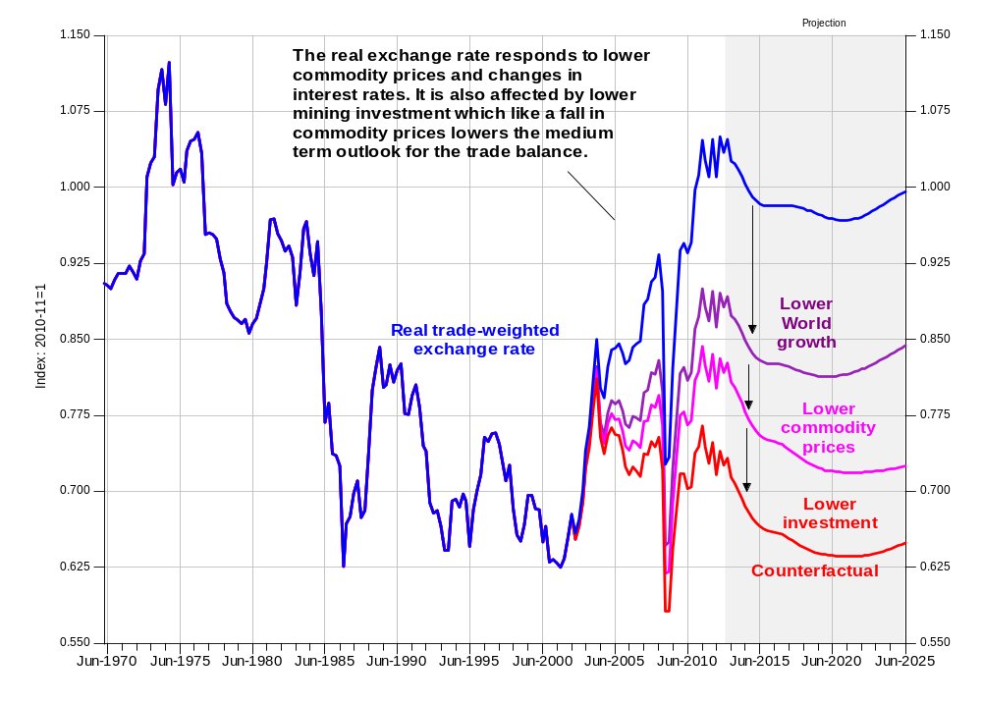
Notes: Real TWI exchange rate is the trade weighted exchange rate adjusted for movements in relative consumer prices.
Data source: RBA Bulletin database, ABS Cat No 5204.0 OECD MEI database, authore estimates and AUS-M model database and simulations.

Activity and Unemployment
Initially the impacts on activity in the counterfactual are relatively small with the exchange rate movement helping to insulate the economy from the activity effects of lower investment (Chart 3). However the absence of the deflationary effect of a rising exchange rate through 2004 to 2007 means that the increase in inflation during the period is more rapid, leading to a faster tightening of monetary policy than otherwise (Chart 11). This in turn leads to higher unemployment which lowers inflation and leads to a larger fall in interest rates during the GFC.
The persistence of unemployment in the model is due to a number of effects. Firstly the Phillips curve is a curve and hence high unemployment has less effect on inflation than low unemployment. Secondly, the wage equation also allows for an asymmetry in the effect of the change in unemployment, so an increase in the unemployment rate has less impact on inflation than an equivalent fall in the unemployment rate. Moreover, the longer the unemployment rate remains high the greater the increase in long term unemployment. Higher long-term unemployment reduces the search effectiveness of the unemployed and hence the level of the NAIRU which is about a third of a percentage point higher by 2013 (Chart 11).
11 Interest Rates and Inflation: Actual and Counterfactual
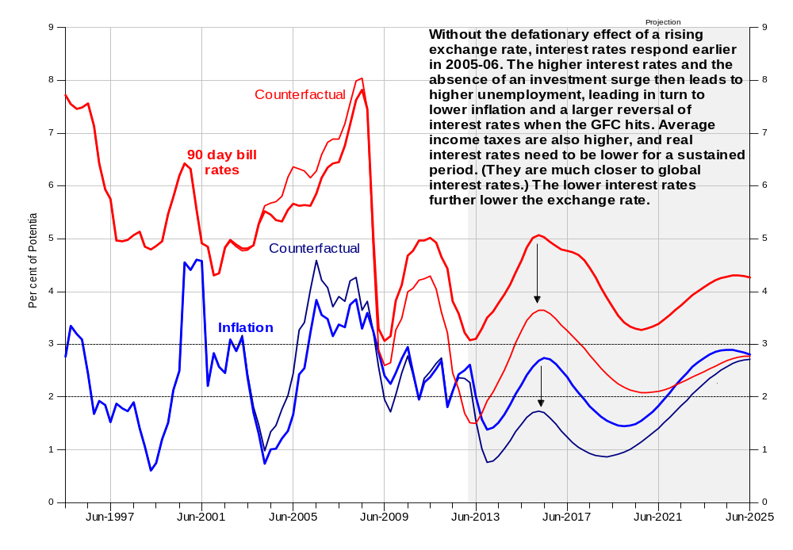
Notes: Inflation is the through the year change in the household consumption deflator
Data source: RBA Bulletin Database, ABS Cat No 5204.0, author estimates and AUS-M model simulations
12 Unemployment: Actual and Counterfactual
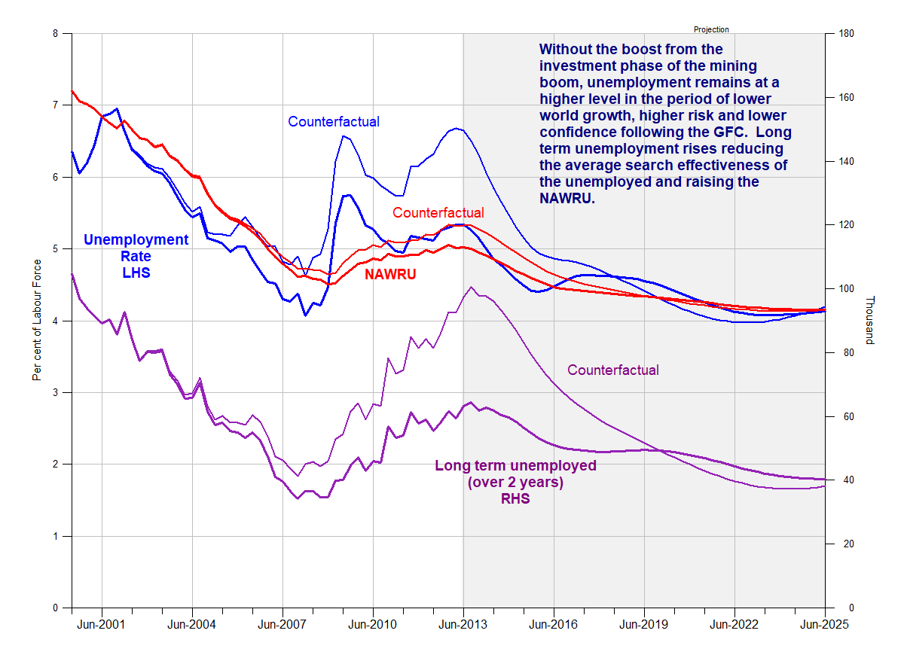
Notes: NAIRU strictly speaking is a NAWRU as it represents the equilibrium from the wage equation.
Data source: ABS Cat No 5206.0, 5204.0, author estimates and AUS-M model database and simulations.

The dwelling sector
The other market that tends to exhibit long periods of disequilibrium is the housing market. (Like the labour market it is characterised by heterogeneity and search and does not clear in the short run.) In the absence of the mining boom, the growth of real incomes and consumption is much lower, and hence the demand for rental services is lower than otherwise. Consequently the rental crisis of 2006-07 does not develop. With higher rental vacancies, rental prices do not increase to the same extent (Chart 13). At the same time interest rates are lower by 2008 leading to higher dwelling investment. This leads to greater dwelling supply in the face of further falls in real incomes and consumption and hence further increases in rental vacancies. Higher vacancies lead to lower real rental prices, which eventually lower the Q ratio even though interest rates are still low (Chart 14). This brings investment back to baseline.
13 Rental vacancies and Rental Prices: Actual and Counterfactual
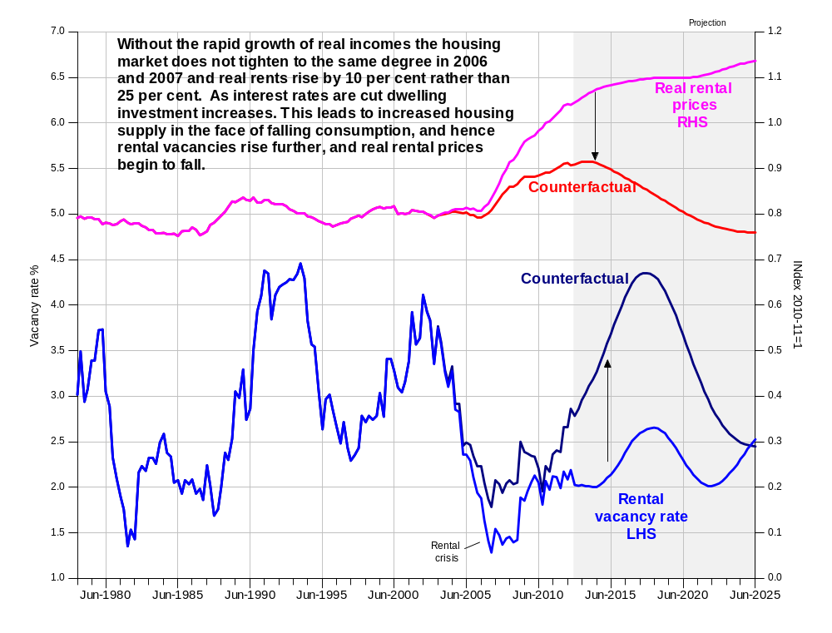
Notes: Real rental prices measured as the deflator for the consumption of rents divided by the deflator for non-rental household consumption. Rental vacancies are a population weighted average of REIA capital city rental vacancies seasonally adjusted.
Data source: REIA Market Facts, ABS Cat No 5204.0, author estimates and AUS-M model database and simulations.
Given that real national income and consumption are falling by around 12 per cent the fact that dwelling investment is higher means that the share of rental services in total consumption is much higher absent the mining boom. So in this case the substitution effects (from lower interest rates, lower construction costs and lower rental prices) are larger than the income effects (at least in the short term).
14 Dwelling Q Ratio and Investment: Actual and Counterfactual
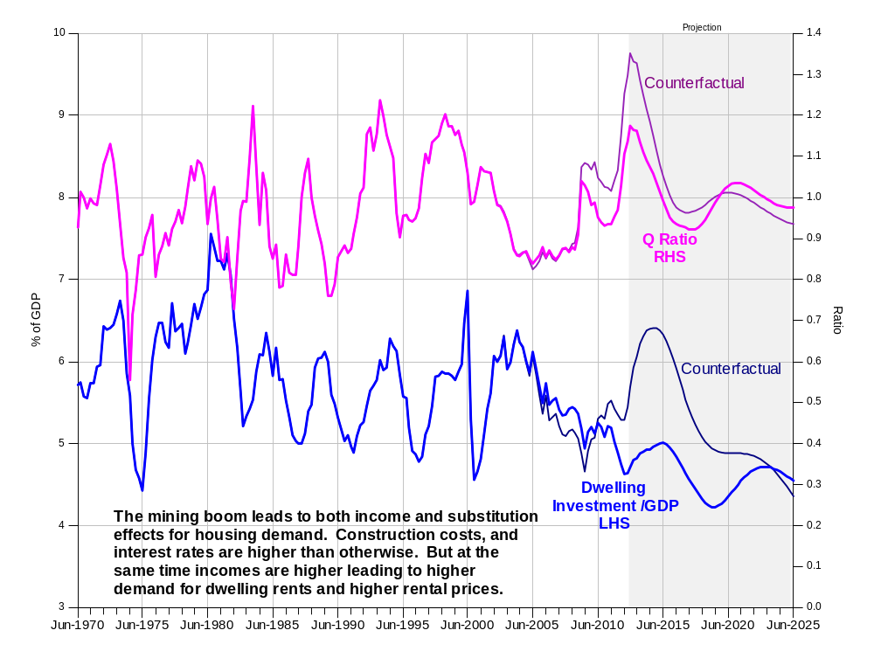
Notes: The dwelling investment Q ratio as measured as the after tax rental return divided by the required rate of return.
Data source: ABS Cat No 5204.0, author estimates and AUS-M model database and simulations.

Consumption, saving and the current account balance
One of the remarkable things about the mining boom is that despite the very large increase in mining investment (and a significant slump in public saving) there has been very little in the way of an increase in the current account deficit or build-up in net foreign liabilities. This is largely due to an increase in both business and household saving, in turn partly due to the response to a once in a lifetime surge in commodity prices. And it is partly due to the effect of the higher exchange rate on investment good prices. Unlike other OECD countries Australia imports most of its machinery and equipment and the 40 per cent appreciation of the exchange rate has led to a 10 to 15 per cent reduction in the cost of investment. Consequently rather than being smaller in the absence of the mining investment boom the current account balance is larger (Chart 16). (The worsening of the current account deficit in the absence of higher commodity prices is possibly partly attributable to the poor levels of productivity growth noted earlier and consequent fall in competitiveness.)
15 Private Savings: Actual and Counterfactual
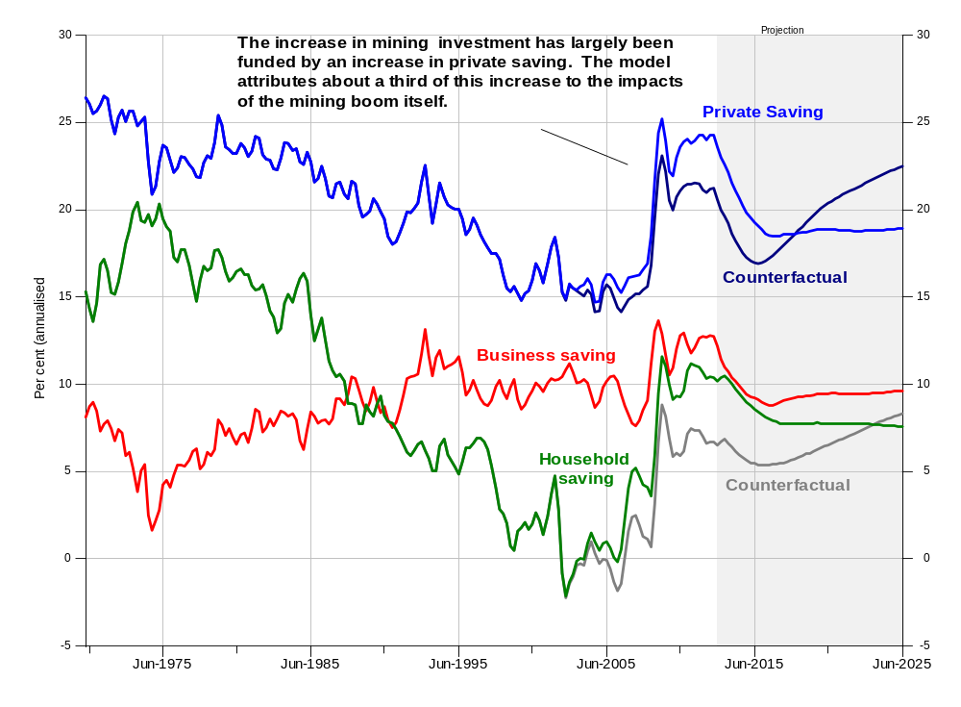
Notes: Series show private gross saving as a percentage of GDP and household (net) saving as a percentage of household disposable income.
Data source: ABS Cat No 5206.0, 5204.0, author estimates and AUS-M model database and simulations.
16 Current Account Balance: Actual and Counterfactual
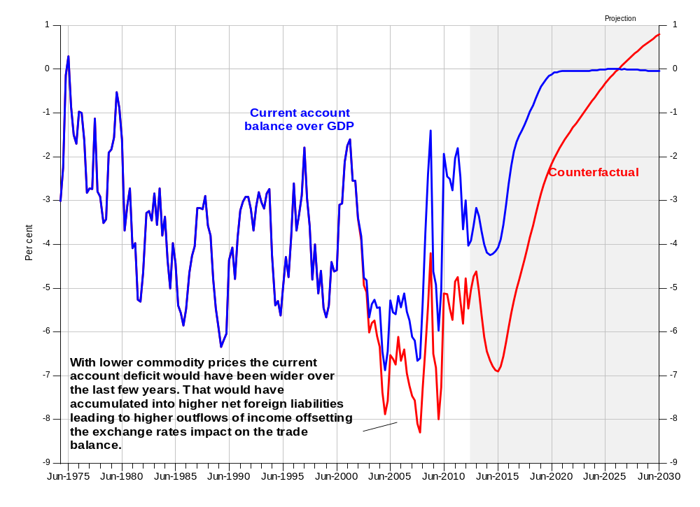
Notes: Series show seasonally adjusted current account balance as a percentage of nominal GDP.
Data source: ABS Cat No 5302.0, 5206.0, author estimates and AUS-M model database and simulations.
The fact that the current account deficit is larger in the absence of the mining boom means that net foreign liabilities are also higher (rather than lower). This means that the net income deficit is also higher (i.e. there is a larger outflow of income in the absence of the mining boom). This is a somewhat counter-intuitive result and requires more examination.

Foreign ownership and income outflows
The exact degree of foreign ownership of mining operations is difficult to ascertain from stock market data and company publications. Connolly and Orsmond on the basis of the available data calculate that it could be around 80 per cent, with the share for iron ore producers a little lower and that for coal and LNG producers a little higher. Gregory and Sheehan note that for some large foreign owned LNG projects, where the platforms and processing plants are manufactured overseas and towed to site off the coast of WA, the impact on the domestic economy is likely to be minimal apart from the resource rent and company income tax paid. Consequently in estimating the impact of higher mining exports on the economy they attribute most of the income to foreign owners. This then leads them to conclude that there is likely to be a significant slump in activity as mining investment falls. The investment activity generates higher domestic incomes when it is happening but the subsequent returns from higher exports flows mainly overseas. Garnaut, 2013, makes a similar case and argues that Australia is in for a protracted period of adjustment as the growth in Chinese demand for commodities slows.
As the model results above indicate, this possibly misses some offsets and feedback effects arising from the mining boom, and in particular the rise in private saving that accompanied the rise in investment. Also it needs to be remembered that the merger and acquisition activity that led to higher foreign ownership of Australian mining companies also left Australians owning significant foreign mining assets. For example the BHP merger with Billiton in 2001 more than halved the share of Australian investors in the merged entity, diluting their ownership of Australian production. But at the same time it meant they became owners of a similar slice of foreign mining assets.
The ABS data on total foreign assets and liabilities by industry (Chart 17) indicate foreign mining liabilities are currently equivalent to 21 per cent of GDP. That is offset by Australian foreign mining assets worth 11 per cent of GDP, a net liability position of 10 per cent of GDP. In comparison the mining capital stock is worth around 33 per cent of GDP at replacement value. (This is likely to be a significant underestimate of the total value of mining assets – the ABS estimates that mining reserves /sub-soil assets are equivalent to more than 60 per cent of GDP. ) The value of the mining capital stock has risen by 16 percentage points of GDP since 2004 while net mining foreign liabilities have risen by about 6 percentage points.
This suggests that the degree of foreign ownership may be somewhat less than 80 per cent; that the net position is much lower, (i.e. that Australian investors still have a significant exposure to resource stocks); and, that Australian residents have funded a reasonable share of the increase in the mining capital stock via higher saving. Unless foreign investment is particularly highly geared this should mean that a reasonable share of the returns from the higher mining capital stock will flow to Australian investors, who also receive income from their foreign mining assets when commodity prices are high. Moreover the returns to the flow of funds into mining investment will not necessarily be exceptionally high (Chart 18). The excess returns are largely in history and accrued to existing capital as commodity prices rose through 2004 to 2008. The average risk adjusted returns on new projects will not necessarily be higher than returns in other industries.
But perhaps the more important point is that the aggregate data indicates that there has been a diversification of investment. Net foreign liabilities in mining have risen since the mid-2000s, but the overall net foreign equity position has remained relatively unchanged (Chart 17). This suggests that portfolio diversification has been occurring, or at least portfolio rebalancing. (For example, with rising valuations Australian investment managers may have found they were overweight in resource stocks.)
Portfolio diversification in theory should be a good thing. In fact most financial studies find that despite the rise in Australian investment overseas since the 1980s there is still a significant home bias in Australian wealth holdings and there could be considerable benefits to greater diversification particularly into Asian markets. Moreover the increase in the ownership of foreign assets means that there is now a positive wealth effect for Australian residents when there is a depreciation of the currency. This helps to insulate the economy from the impact of a terms-of-trade slump.
17 Foreign Equity Liabilities and Assets
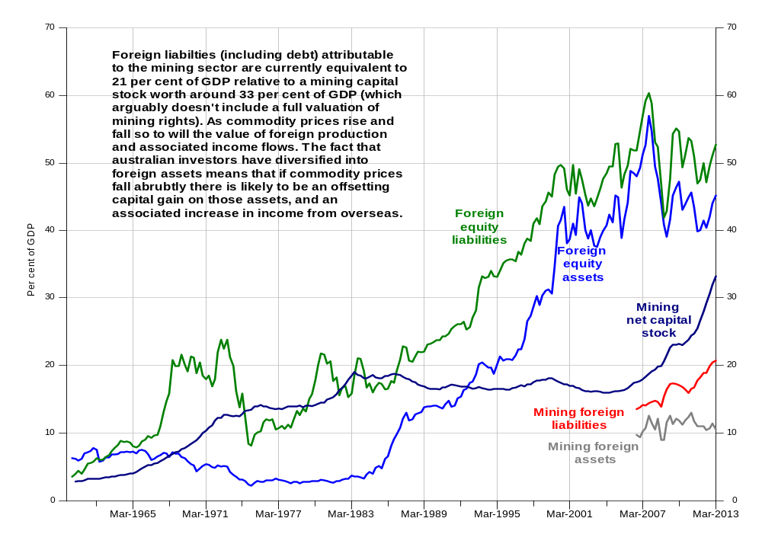
Notes: Mining foreign assets and liabilities include both debt and equity assets and liabilities attributable to the sector.
Data source: ABS Cat No 5302.0, 5204.0,,5206.0 author estimates and AUS-M model database and simulations.
18 Net Rates of Return on Capital – Selected Industries
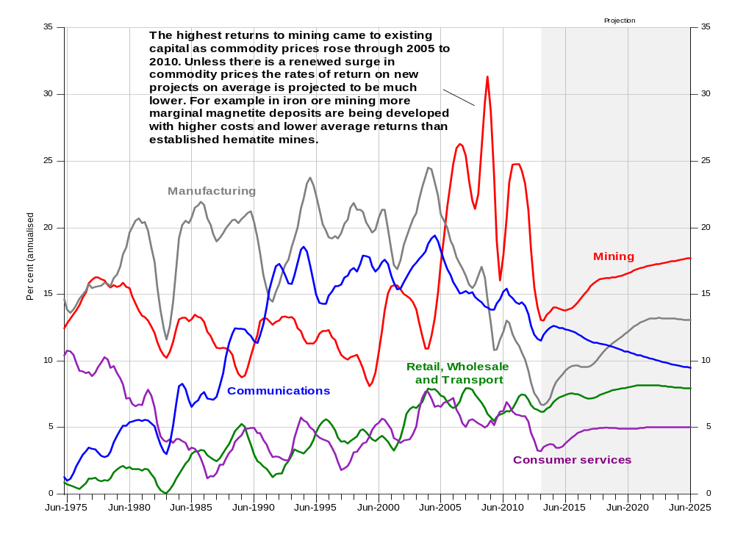
Notes: Net rate of return is calculated as GOS less economic depreciation divided by the capitals stock at replacement value times 100. GOS is measures as gross mixed income less wages attributed to employers and self-employed. Mining GOS is after taxes on production such as royalties but before taxes on income such as the MRRT and PRRT.
Data source: ABS Cat No 5206.0, 5204.0, author estimates and AUS-M model database and simulations.
So overall there doesn’t appear to be a particularly large reason to be concerned about a slump in the growth of national income due to a rise in income flowing to overseas investors in the mining industry. In fact the opposite occurs in the model projections. Net outflows to foreign investors decline. The average return to mining projects is not particularly high and the overall level of net foreign liabilities is lower as a result of the boom. In the absence of the mining boom, savings and wealth would have been lower and the net income deficit higher.

Overall response
The aggregate impacts of the shock on activity and national income in the model reflect a combination of effects. Firstly lower commodity prices translate into a lower terms of trade which lowers national income by around 5 per cent. Then, because mining investment and output are lower and the national capital stock is lower, productivity and national output are lower. The 10 per cent fall in national income (Chart 10) reflects both the direct terms of trade effect on income and the subsequent effect on investment and activity.
19 GDP and National Disposable Income: Deviation from Baseline
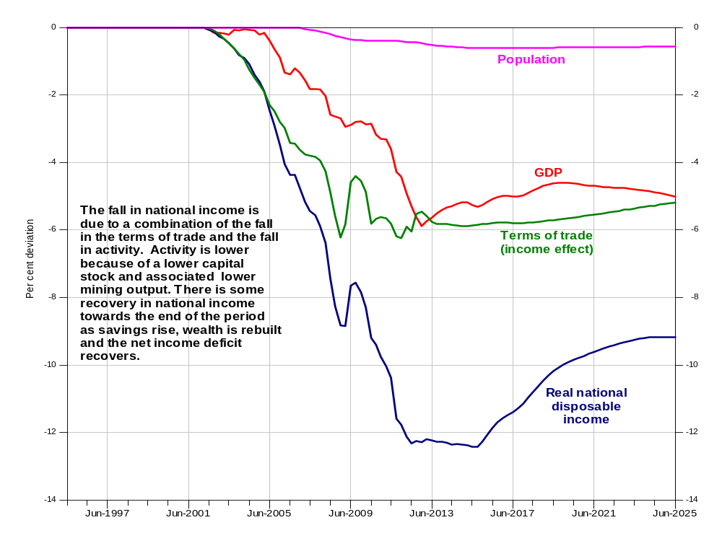
Notes: Real disposable income is measured as nominal disposable income divided by the deflator for GNE. Alternatively if consumer prices were used as the deflator the fall in real national income would be a percentage point smaller by 2013.
Data source: ABS Cat No 5204.0, author estimates and AUS-M model database and simulations.
The impact on consumption involves a few extra layers of responses, and hence is probably surrounded by a wider range of uncertainty. As the capital stock is lower, labour productivity is lower and hence real wages need to be lower in the medium to long-term. The adjustment to lower real wages requires a period of higher unemployment. However once wages adjust employment returns to the baseline levels. In addition the tax base is lower and hence average tax rates are higher leading to lower household disposable income. On top of this, wealth is lower (due to a combination of lower equity prices, lower saving and hence wealth accumulation). Hence property income is lower leading to lower household disposable income. Initially savings are lower reflecting the view of households that the boom was probably providing a temporary boost to income. In the medium to long run as it becomes apparent that the change in incomes is permanent, savings rise to rebuild wealth. (Or alternatively in the baseline with the mining boom, savings rates eventually fall as households adjust to the higher levels of income and wealth.) In the long-run consumption will adjust to be consistent with the fall in household disposable income which is around 11 per cent lower per capita in the absence of the Mining Boom.
20 Household Income and Consumption: Deviation from Baseline
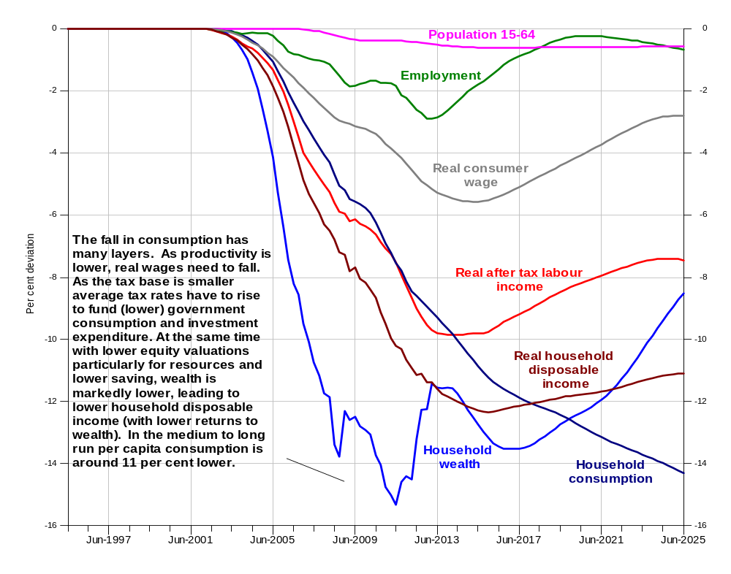
Notes: Real consumer wage is defined as the labour quality adjusted hourly wage rate divided by the national accounts consumption deflator. Real household disposable income is as defined in the ABS QNA household income and outlay accounts.
Data source: ABS Cat No 5204.0, 6203.0, author estimates and AUS-M model database and simulations.
The fall in consumption relative to baseline indicates that there would have been very little growth in consumption per capita over the last ten years in the absence of the mining boom. In comparison to 15.3 per cent growth in the baseline in the 10 years to end 2014, growth in the counterfactual is 4.5 per cent. Why so low? The main reason is the slow-down in underlying labour productivity growth (Chart 22). If labour productivity grows at 1 percentage point less per year it quickly accumulates into an income effect as large as that of the mining boom. The low productivity growth and hence income growth over the last 10 years probably explains why most households don’t particularly feel they are in the middle of an incomes boom. What the mining boom has given, low productivity growth has taken away.
21 Consumption per capita – Actual and Counterfactual
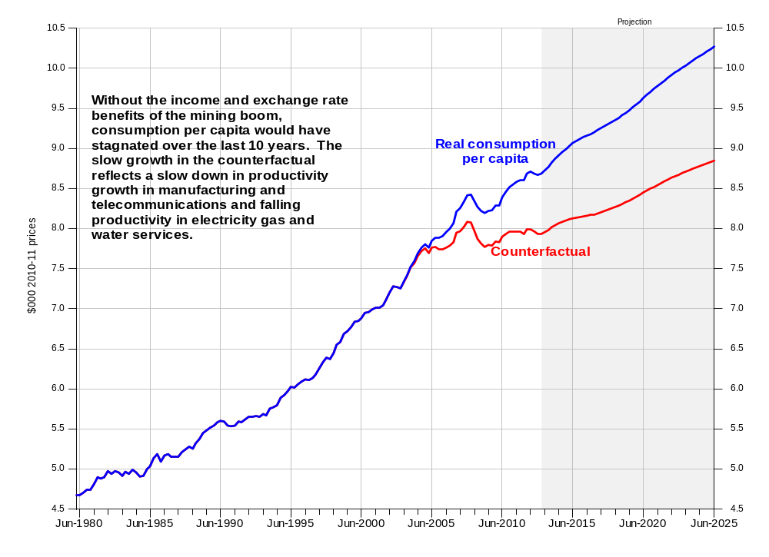
Notes: Real consumption per capita defined as QNA household consumption divided by residential population.
Data source: ABS Cat No 5204.0, 3101.0, 6203.0 author estimates and AUS-M model database and simulations

22 Underlying labour productivity in the non-commodity sector
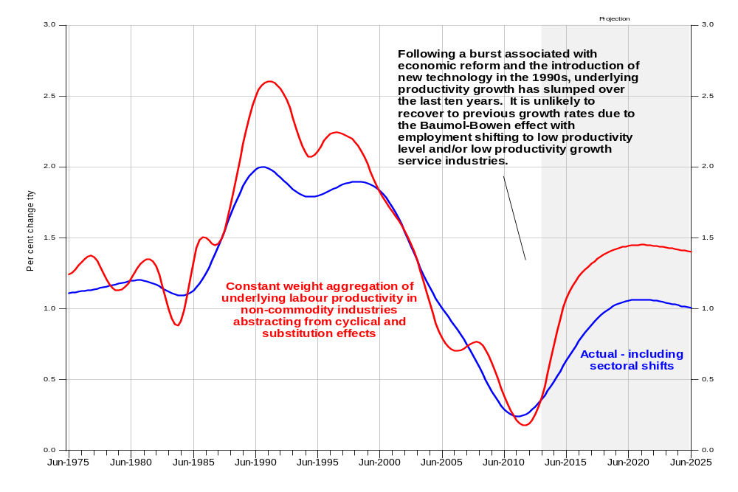
Notes: Underlying productivity in the non-commodity sector is a geometric chain-weighted aggregation of underlying labour efficiency in non-commodity industries. Underlying labour efficiency in turn is derived from the estimation of the industry production function equations and is a stochastic trend abstracting from cyclical and substitution effects. As changing labour quality contributes around 0.3 to 0.4 per annum to productivity growth, the contribution from all other factors (technology, innovation, organisation change etc.) has been negative over the last few years.
Data source: ABS Cat No 5204.0, 3101.0, 6203.0 author estimates and AUS-M model database and simulations

Consumption details
The impacts of the shock on industry and employment depend in part on the pattern of response of consumption and trade to relative price movements and changing income. For consumption, the largest movements in relative prices are due to the lower exchange rate in the counterfactual. This drives the prices of imported goods like motor vehicles and durables higher, while those of goods and services produced domestically remain relatively unchanged (Chart 23a). As durables and motor vehicles are discretionary they are also affected by the fact that real household disposable income is around 12 per cent lower (Chart 20). The combination of the substitution and income effects mean that motor vehicle purchases may have been 30 per cent lower in the absence of the mining boom, and durables 25 per cent lower (Chart 23b). But at the same time the operation of motor vehicles (the number of trips made and distance travelled) is less affected. (The price is relatively unchanged as we have assumed world oil prices are lower so landed import prices for petrol are lower even with the lower exchange rate.)
Consequently in the absence of the mining boom there probably would have been a lot fewer new cars and SUVs on the road, and fewer flat screen TVs in our homes. Australians would still have been driving about as far, but on average in much older cars. Hence it’s interesting to speculate there may have been more accidents and break-downs, and air pollution in our major cities would possibly have been higher.
23a Consumer Prices – Selected Components: Deviation from Baseline
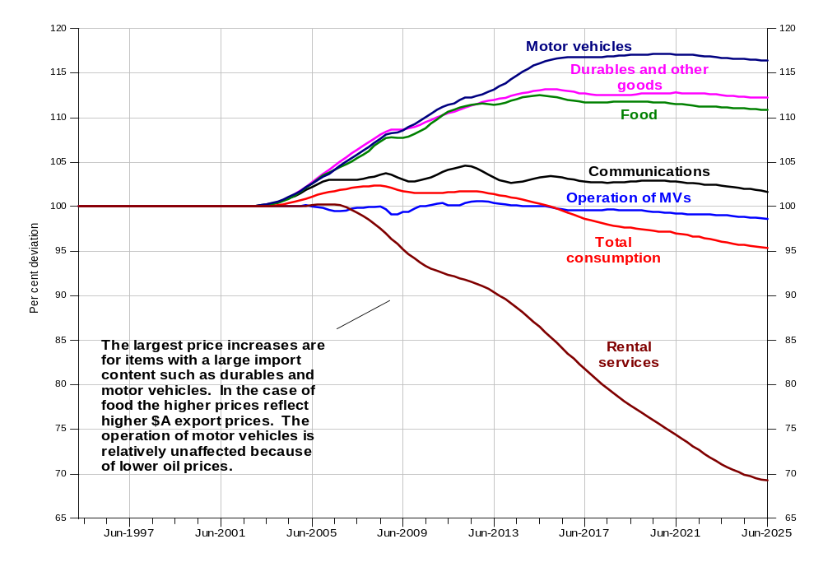
23b Household Consumption – Selected Components: Deviation from Baseline
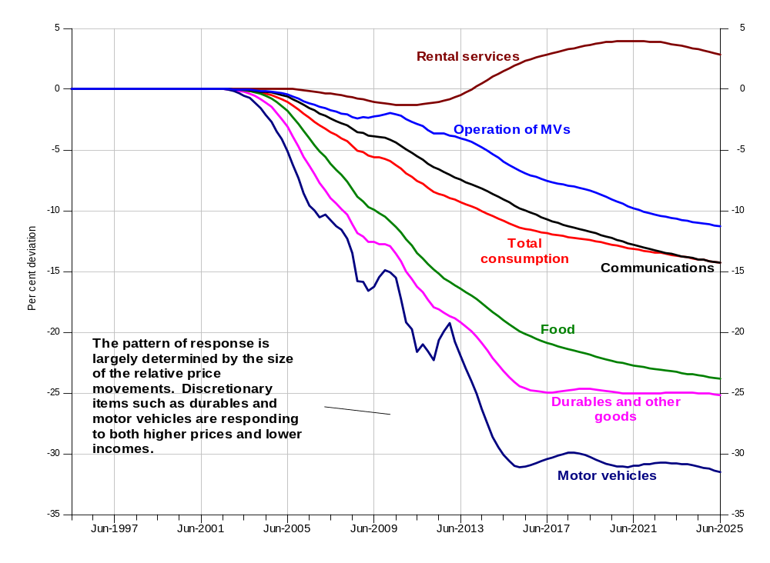
Data source: ABS Cat No 5204.0, 6203.0 author estimates and AUS-M model database and simulations

Business investment
The other major component of demand affected by the relative price changes driven by the mining boom is business investment. In theory higher investment in mining should crowd out investment in other sectors. The distribution of effects by industry in the counterfactual simulation is shown in Chart 24 below.
24 Business investment – selected industries – deviation from baseline
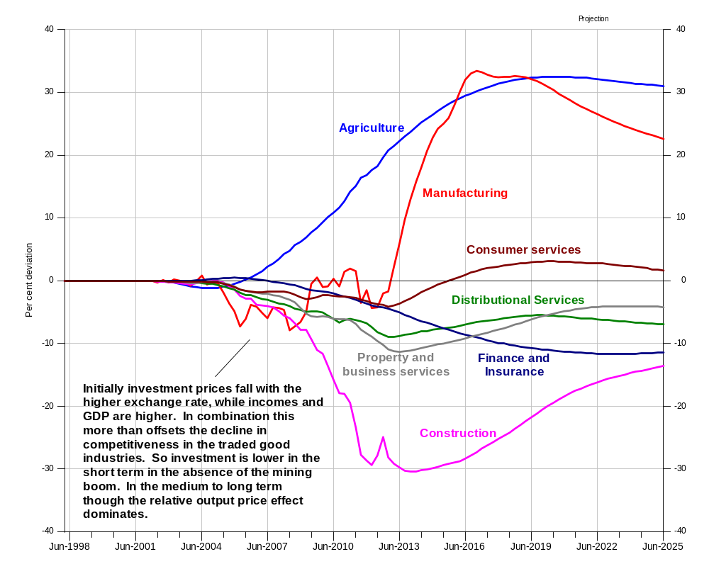
Notes: Series show per cent deviation of levels in the no-mining boom counterfactual from baseline.
Data source: ABS Cat No 5204.0, 6203.0 author estimates and AUS-M model database and simulations.
It is interesting to note that in the short term, investment in manufacturing is actually lower in the short-term (first five years) in the absence of the mining boom. This is because in the short term higher demand for inputs to construction from manufacturing offsets the loss of competitiveness from the higher exchange rate, so that output and profits are relatively unaffected (see below). At the same time investment equipment prices fall by 20 per cent with the higher exchange rate. Consequently the investment Q ratio for manufacturing is actually higher in the short term. (Firms buy more equipment in the same way that households buy more flat screen TVs.) But in the medium to long run, particularly after the initial burst of mining investment begins to fade, the relative price effects dominate. (This is similar in some ways to Bean’s results for North Sea oil. In the resource discovery /investment phase the increased demand for manufacturing output offsets the relative price effects. In the oil price shock phase, without an accompanying surge in investment, the relative price effects dominate.)
The pattern of results across industries in the medium to long run largely reflects their degree of trade exposure and the degree of linkage to mining. Agriculture which is highly dependent on the export market and has few linkages to mining is the most adversely affected. Construction with its strong linkages to mining investment is the most positively affected, as are industries with some association with the level of investment such as finance and insurance and property and business services. Distributional services (transport and storage and wholesale and retail trade) as margin industries tend to reflect the overall level of activity.
The mining boom has also led to a large change in the composition of business investment (Chart 25). This mainly flows from the fact that the new mining projects involve a lot of construction activity (Chart 6). But it is also due to the fact that agriculture and manufacturing are both equipment intensive. As manufacturing and agricultural investment decline the demand for equipment investment falls. The decline in imported capital goods is one factor which helps to support activity as the economy adjust in the second phase of the mining boom.
25 Business investment by asset – deviation from baseline
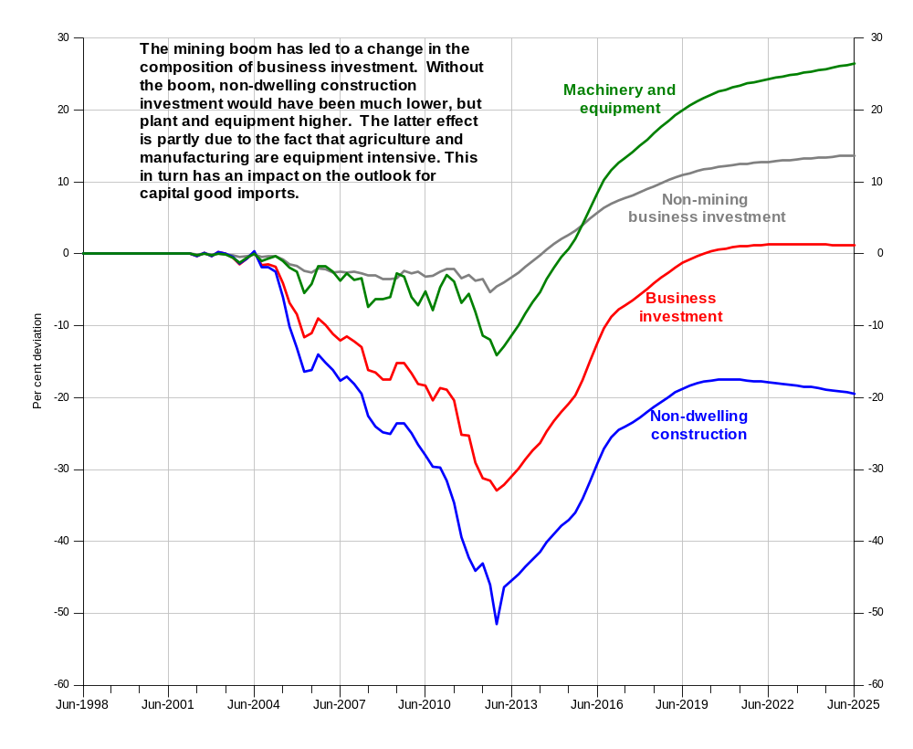
Notes: Series show per cent deviation of levels in the no-mining boom counterfactual from baseline.
Data source: ABS Cat No 5204.0, 6203.0 author estimates and AUS-M model database and simulations.
Obviously there are many qualifications to the investment responses across industries. In particular the results depend on the degree of forward looking behaviour. For example, if manufacturing firms were fully informed investment probably would be lower in the short-term.

Export details
Exports (driven by global demand) are the final element on the demand side. Obviously mining exports are much higher with the mining boom, and the exchange rate appreciation is the major factor reducing the competitiveness of non-mining exports. To understand the results a short aside is probably required here on how exports are modelled in AUS-M. For commodity exports (agriculture and mining) the assumption is made that goods are reasonably homogenous and that producers are price takers on the world market. As a consequence the volume export response is largely invariant to short term fluctuations in global demand (volume of trading partner imports). Rather they are dependent on relative prices or ‘internal competitiveness’, (the world price expressed in $A relative to local costs) and hence profitability. Consequently mining and agricultural exports are determined by supply in the short term and respond with a lag to an increase in demand (requiring a period of higher investment). In contrast manufacturing and service exporters are assumed to face a downward sloping demand curve, and only supply part of their output to the export market (i.e. set the price). They are consequently driven by ‘external competiveness’, (the price of exports in foreign currency on the world market relative to world prices) and are directly affected by fluctuations in world activity (shifts in the demand curve). Which is a long way of saying that: exchange rate changes and fluctuations in world activity have much more immediate effects on manufacturing and service exports.
This comes into play in the present shock. The main thing driving the rise in commodity prices in the boom is the rise in Chinese and world demand. In the counterfactual Chinese and world activity is lower. In the absence of this activity commodity prices and the exchange rate are lower, as is the demand for manufacturing and service exports. Service export demand is more price sensitive than manufacturing export demand and hence they respond by more to the lower exchange rate (Chart 26). For manufacturing, the two effects are broadly offsetting and hence there is not a great deal of change (Chart 26). For agricultural exports (not shown) the lower world demand has a relatively small effect on world prices, so the dominant effect is the lower exchange rate. With higher profitability and investment (Chart 24) supply increases and exports are about 20 per cent higher after a decade.

26a Mining and Manufacturing and Service Exports: Actual and Counterfactual
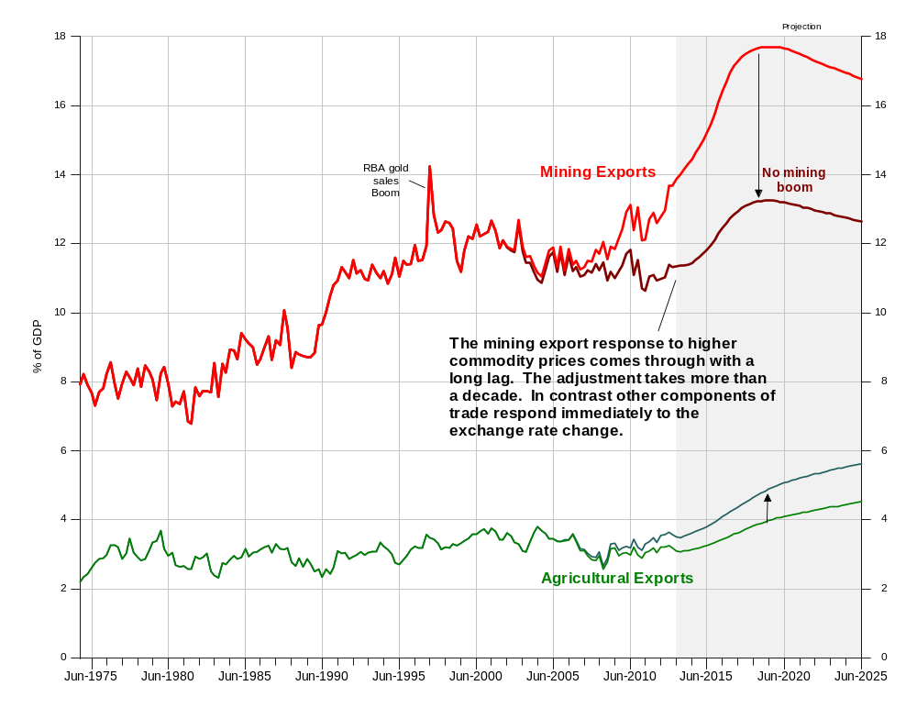
26b Manufacturing and Service Exports: Actual and Counterfactual
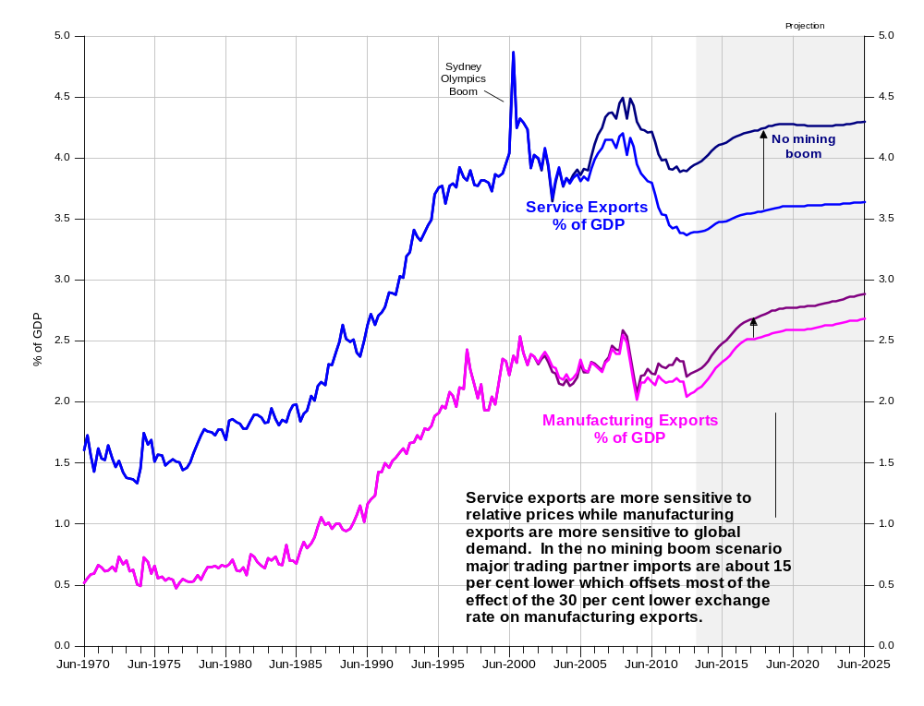
Notes: Series are at constant 2010-11 prices and expressed as a percentage of GDP.
Data source: ABS Cat No 5206.0, author estimates and AUS-M model database and simulations.
So the major fallout from the mining boom is for service and agricultural exports rather than manufacturing exports. Although manufacturing exports increased through the 1990s, Australian manufacturing still mainly services the domestic market. The main impact of the mining boom on manufacturing is therefore felt via import substitution from the higher exchange rate, particularly in the post investment boom phase.

Supply side responses - industry and import details
The pattern of industry responses is determined by two things:
- The pattern of consumption, investment and export responses discussed above. These are mapped back to individual supply side items via input-output coefficients.
- Price driven substitution effects between different components of supply (industry outputs and imports). In the counterfactual simulation these are mainly driven by the lower exchange rate.
How this works is illustrated below for the case of manufacturing (Chart 27). In the short term the higher incomes and expenditure associated with the mining boom drive the demand for manufacturing output higher (lower in the chart which compares the no mining boom counterfactual with the baseline). But at the same time the 40 per cent appreciation of the exchange rate makes it less competitive. As the investment boom fades, and with it the demand for construction inputs from manufacturing, the relative price effects begin to dominate.
27 Manufacturing Output: Demand and Relative Prices
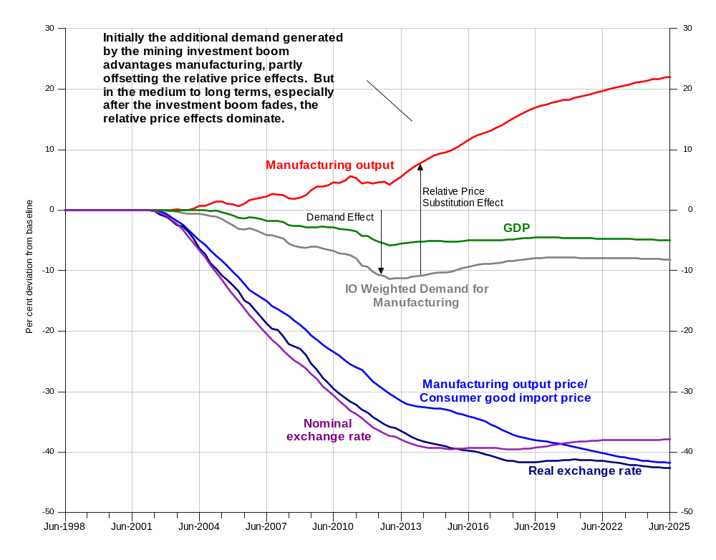
Notes: Series are percentage deviation of the no mining boom counterfactual from baseline levels except for relative prices and exchange rates which are log_{n} deviations times 100.
Data source: ABS Cat No 5204.0, 5206.0, RBA Bulletin, author estimates and AUS-M model database and simulations.
Adding to the problem for manufacturing is that a shrinking market share means that further increases in prices are eventually needed to restore margins, leading to further substitution. (Net rates of return on capital in manufacturing are shown in Chart 28.)
28 Manufacturing Net Rate of Return: Actual and Counterfactual
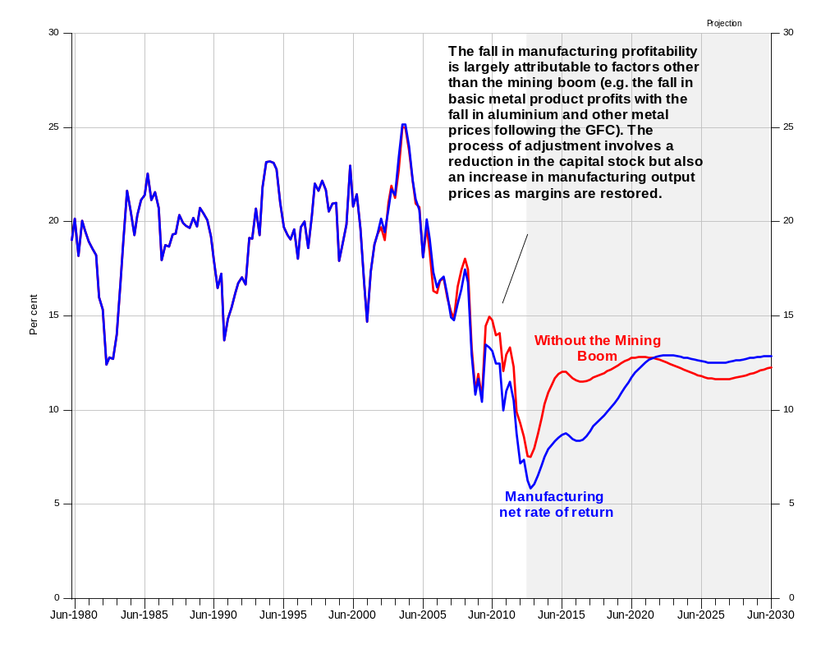
Notes: The net rate of return is calculated as gross mixed income less WSS attributed to employers and self-employed, less economic depreciation over the net capital stock valued at replacement cost – quarterly data expressed at an annual rate.
Data source: ABS Cat No 5204.0, 5206.0 author estimates and AUS-M model database and simulations.
Similar logic applies to other components of supply such as consumer goods imports shown in Chart 29 below. In this case the demand and relative price effects are working in the same direction. Higher import prices in the counterfactual lead to substitution away from imported items within the consumption bundle (Chart 23). That lower level of expenditure is then traced back to consumer goods imports via the input output coefficients. Then there are additional relative price effects as substitution occurs between imports and other sources of supply (such as manufacturing).
29 Consumer Good Imports: Demand and Relative Price Substitution Effects
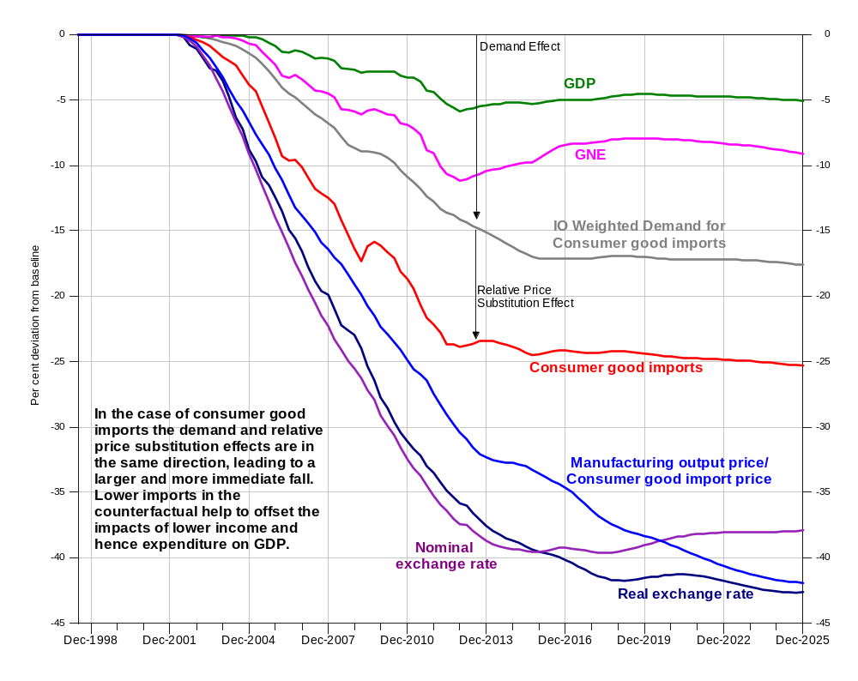
Notes: Series are percentage deviation of the no mining boom counterfactual from baseline levels except for relative prices and exchange rates which are log_{n} deviations times 100. The IO weighted demand term does not capture all the demand effects as part of non-farm stock-building is attributed to imports
Data source: ABS Cat No 5206.0 5302.0 RBA Bulletin Database author estimates and AUS-M model database and simulations.
Resulting deviations in output can be seen in Chart 30b and the resulting change in shares of GDP in Chart 31. Consistent with previous studies the largest impact of the mining boom in terms of prices and hence profits, investment and output, is on agriculture. It is an industry heavily dependent on the export market and gains little benefit from the surge in domestic incomes and demand associated with the mining boom. However the result is dependent on the assumption that world agricultural prices are little affected by lower global activity and industrial production. If alternatively it were assumed that world agricultural prices would have been 20 or 30 per cent lower then this would bring the results for agriculture back towards the pack.
30a Industry Output Prices: Deviation from Baseline
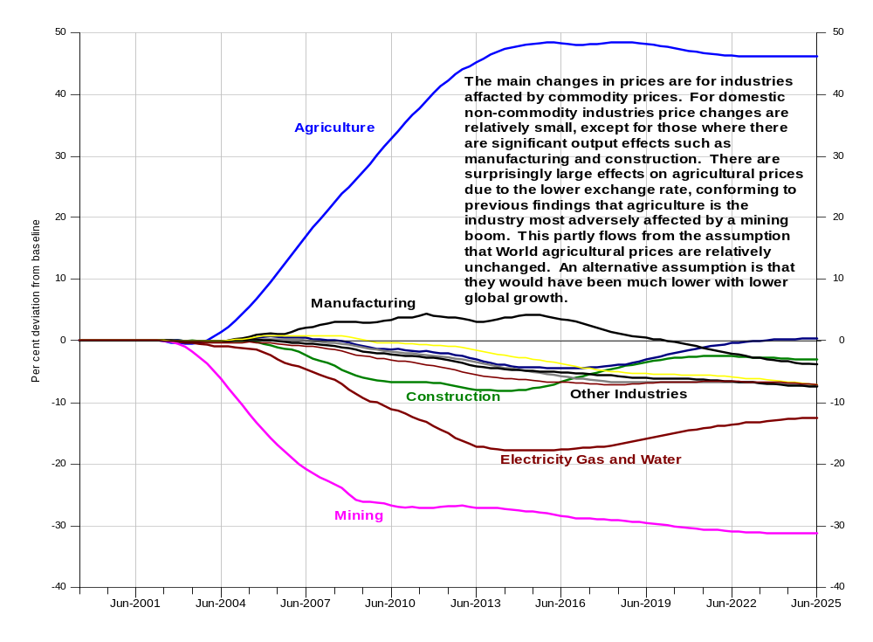
30b Industry Output: Deviation from Baseline
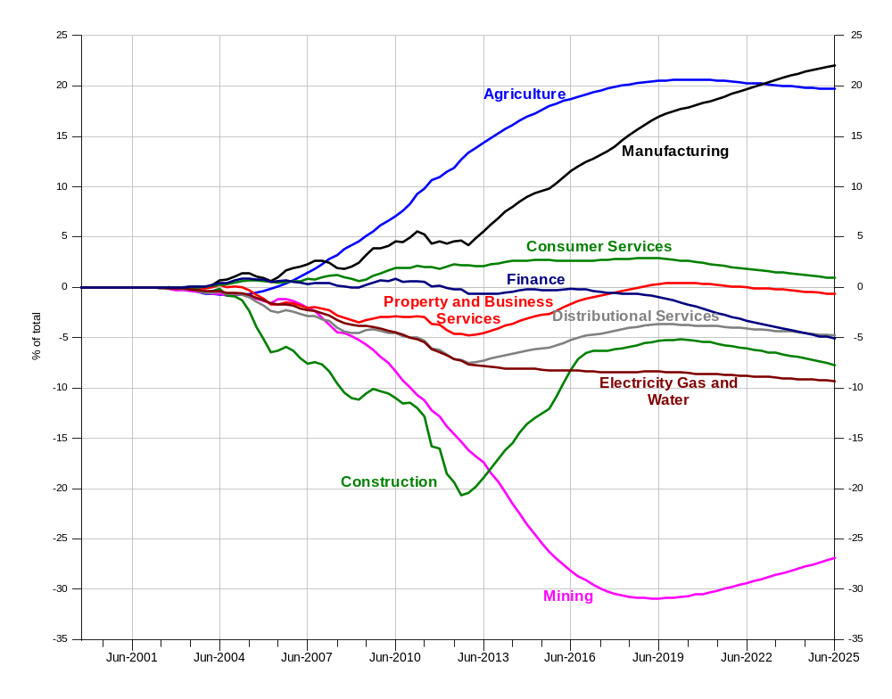
Notes: Industry output is the chain volume measure of value added and prices are for the same concept, i.e. value added rather than gross output. Series are percentage deviation of the no-mining boom counterfactual from baseline levels.
Data source: ABS Cat No 5206.0 5302.0 RBA Bulletin Database author estimates and AUS-M model database and simulations.
31 Output Shares in GDP: Actual and Counterfactual: Selected Industries
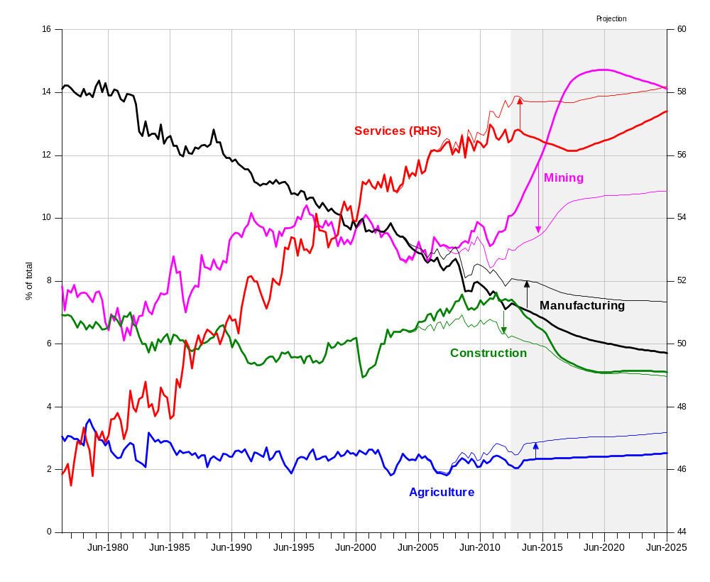
Notes: Series are constant price value added by industry as a percentage of GDP.
Data source: ABS Cat No 5204.0 5206.0, author estimates and AUS-M model database and simulations.
As discussed above, manufacturing is relatively little affected during the mining investment phase with offsetting impacts from increasing overall demand and increased import substitution. Output is around 4 per cent lower by early 2013, a reduction in growth of 0.4 per cent a year spread over a decade, so even the absence of the mining boom manufacturing’s share of total output would still be in decline (Chart 31). The largest impacts on activity so far have been on construction. However both construction and manufacturing have large adjustments yet to come, which in turn will have a significant impact on the demand for blue collar workers.

Employment by industry
The pattern of deviations of employment by industry (Chart 32 below) is largely driven by the pattern of output by industry (Chart 30b above). Where there is a difference (between the two patterns) it is due to changes in producer real wages. (These in turn are mainly due to deviations in output prices. Wage movements are largely felt in common across industries.) For example, mining employment falls noticeably before the fall in output, because mining export and output prices are lower in the counterfactual and hence real producer wages higher. (This leads to substitution away from labour for a given level of output.) Similarly manufacturing employment is 9 per cent higher by mid-2013, compared to an output deviation of 5 per cent. This is because manufacturing output prices are higher, producer real wages are lower and hence there is substitution towards labour for a given level of output.
These substitution effects have an impact on measured labour productivity. For example labour productivity fell in the mining sector when commodity prices rose in the mid-2000s, something the model attributes to a substitution effect rather than a decline in underlying labour efficiency. Similarly, if or when commodity prices decline in the projection period, measured labour productivity in mining should rise. The same applies to other industries where there are large movements in output prices as a result of the shock.
32 Industry Employment: Deviation from Baseline
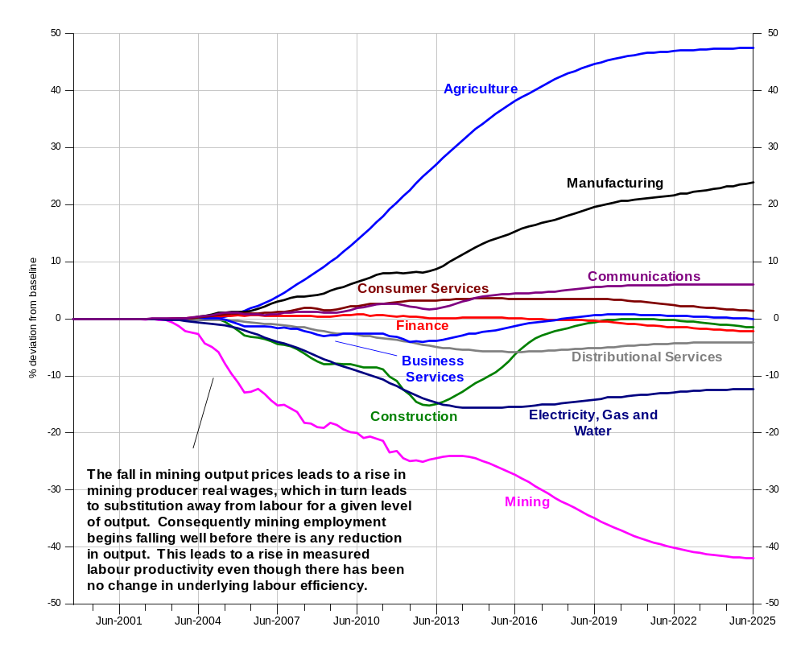
Notes: Industry employment is measured on a heads basis. Similar deviations are seen on an hours worked basis. Series are percentage deviation of the no-mining boom counterfactual from baseline levels.
Data source: ABS Cat No 5206.0 5302.0 RBA Bulletin Database author estimates and AUS-M model database and simulations.

Changing macroeconomic responses
The changes in the economy driven by the mining boom discussed above are so large that they have changed how the economy responds to a variety of shocks.
Perhaps the largest change is in the key one: the response of the exchange rate to commodity prices (which has over the last 30 years acted as a shock absorber for activity in response to the fluctuations in national income). In the baseline mining exports have roughly doubled in value since the 1990s as a percentage of GDP. This means that the impact of any given change in commodity prices on the trade balance and the terms of trade is now roughly twice that of the 1990s. Hence a given change in mineral commodity prices will have or will need to have roughly twice the effect on the exchange rate than they did a decade ago. At the same time the rise of bulk commodities relative to basic metals (which have forward markets) makes this automatic linkage less likely to occur (Chart 33). So in short the response of the exchange rate to a change in mineral commodity prices now needs to be twice as large, but that response is likely to be less reliable or timely than in the past.
33 Bulk Commodities and Metal Exports: Per Cent of GDP
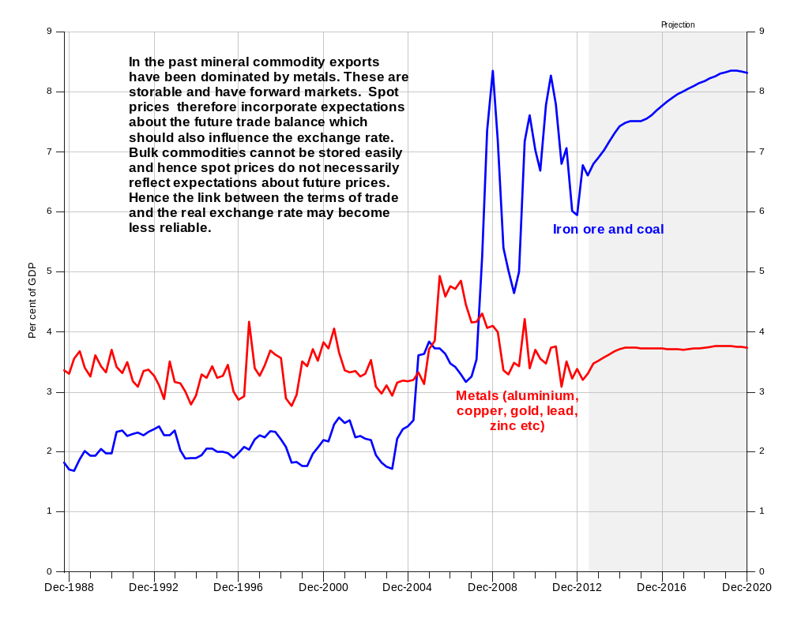
Notes: Series are expressed as a percentage of nominal GDP.
Data source: ABS Cat No 5302.0 BREE, author estimates and AUS-M model database and simulations.
At the same time the changed composition of exports has reduced the response of net exports to the exchange rate (in turn an important linkage for monetary policy). The rise of mining exports has also led to lower levels of service and manufacturing exports (Chart 26b) which are more sensitive in the short term to exchange rate changes. (Offsetting this imports, which are also sensitive, are higher.) The long response times involved in the mining industry mean that a given exchange rate change will now take longer to have an impact on net exports. It means that the short term response of net exports as a percentage of GDP is roughly 10 per cent smaller than it was ten years ago.
At the same time the mining boom has had the indirect effect of reducing dwelling investment as a percentage of GDP (Chart 14). As both net exports and dwelling investment are key linkages for the impact of monetary policy on GDP, these developments have arguably reduced the impact of a given change in interest rates.
Meanwhile the increase in commodity exports has increased Australia’s exposure to fluctuations in world industrial production. Industrial production has now largely moved to developing and emerging countries, which have higher but less stable growth rates than advanced countries (the GFC excepted). At the same time, as mentioned the exchange rate seems likely to be less reliably linked to the terms of trade than in the past. This combination of factors is likely to lead to a more challenging environment for macroeconomic policy in the years ahead, for example possibly leading to situations where the zero bound to interest rates comes into play (or increasing the likelihood that could happen). Insofar as monetary policy is less effective, the crowding out of fiscal policy is reduced, which in turn suggests that fiscal policy may have a larger role to play in the future, or at least that close coordination of monetary and fiscal policy will become more important.

Conclusion
The question we asked at the start of this exercise was: what effect has the mining boom had on the economy? That in turn led to an immediate second question: what do we mean by the term mining boom? Exactly what set of events is implied? To answer the first question involved considering not one shock but rather a set of shocks to capture the factors involved in generating the mining boom. This in itself led to some initial findings:
- First we found that the rise in mineral commodity prices was not solely due to increasing world demand, (perhaps a third was due to supply side factors such as planning lags after a long period of low prices.)
- Second when we then removed the commodity price shock we found that commodity prices themselves only explained part of the surge in mining investment (with perhaps a third being due to innovations enabling the exploitation of coal seam gas reserves and developments in Asian gas markets that created the conditions for the long-term contracts underpinning some projects to be signed).
These results suggest that it was not only the rise of Asia, but also other factors – a confluence of events – that led to the extraordinary surge in mining investment. That in turn meant stripping out the mining boom involved a series of shocks and adjustments. The main components of the resulting counterfactual shock were: (a) lower world growth and industrial production (the non-rise of Asia); (b) lower world commodity prices (adverse market developments); and (c) lower mining investment (no coal seam gas LNG developments).
Many of the results are as would be expected. For example, the improving terms of trade (relative to the counterfactual) adds around 5 per cent to national income and the expanding capital stock doubles this to around 10 per cent. The increase in the capital stock has been funded by an increase in private saving, so there is no increase in income outflows required to service the extra capital – it is owned by Australian residents (who have diversified their wealth holdings away from mining). With a larger capital stock, labour productivity is higher. Consequently wages are higher and with lower tax rates due to higher government revenue, household disposable income and wealth are both increased by around 11 per cent. Reflecting this consumption per capital is around 11 per cent higher than otherwise.
But some results are surprising. For example the simulation results indicate that the current account balance would have been larger in the absence of the mining boom and the level of net foreign liabilities higher. Similarly the impacts to date of the mining boom on manufacturing profitability, investment and output are surprisingly small. For manufacturing, higher demand and cheaper imported equipment and inputs have offset some of the impacts of the high currency. The main adjustment is yet to come as the stimulus from higher mining investment fades, market shares fall and energy costs rise.
At the same time the rental crisis and the housing shortage that developed during 2006-07 has a surprising lot to do with the mining boom. The boom was adding to incomes and demand for housing services at the same time as it was crowding out supply via higher interest rates. The distributional impacts of this seem quite marked. Established home owners and high income earners have seen their wealth increase. Those who can afford them have found new cars, flat screen TVs and overseas holidays falling in price, while for the young and those on low income, rents have climbed by 30 per cent and essential household utilities become more expensive. So as the result show, the mining boom has bought great benefits, but it is possible to infer that they haven’t necessarily been evenly distributed
The mining boom and the rise of commodity exports is also changing the way the economy operates at the macroeconomic level, and throwing up new challenges for policy makers. The economy is now more exposed than previously to an external environment which is likely to be less stable. Terms of trade fluctuations are likely to continue to be volatile. At the same time the exchange rate may become a less reliable shock absorber to the resulting fluctuations in national income, and monetary policy less effective in influencing the level of demand. These developments point to a more challenging macroeconomic policy environment in the future, one that will arguably require close coordination between Australia’s monetary and fiscal policy institutions.
None of these results are written in stone and all depend on linkages and assumptions which are open to debate. But hopefully the results above and in the appendixes have provided a framework for thinking through some of the problems, and made a contribution to quantifying some of the many ways the economy is changing.

References
Banks, G., 2011, “Australia’s Mining Boom: What’s the Problem?” address to the Melbourne Institute, Economic and Social Outlook Conference, 30 June, Melbourne.
Bean, C., 1987,“The Impact of North Sea Oil”, in Dornbusch R., and Layard R., 1987, The Performance of the British Economy, Clarendon Press, Oxford.
BREE (Bureau of Resource and Energy Economics, 2013, Resources and Energy Major Projects April 2013, Canberra, May.
Cagliarini A., and McKibbin, 2009, “Global Relative Price Shocks: The Role of Macroeconomic Policies”, RBA (Reserve Bank of Australia) Research Discussion Paper No 2009-10, Sydney, December.
Connolly E., and D. Orsmond, 2011, “The Mining Industry: From Bust to Boom”, RBA Research Discussion Paper No 2011-08, RBA, Sydney.
Commonwealth Treasury, 1996, TRYM Model Users’ Guide, AGPS, Canberra.
Cook, L., and E. Seiper, 1984, “Minerals Sector Growth and Structural Change”, in L. Cook and M. Porter (eds) The Minerals Sector and the Australian Economy, George Allen and Unwin, Sydney.
Corden, W., and J. Neary, 1982, “Booming Sector and De-Industrialisation in a Small Open Economy”, The Economic Journal, Vol.92, No.368, pp.825-848.
Deaton, A., and J. Muellbauer, 1980, “An Almost Ideal Demand System”, The American Economic Review, 70(3):312-326
Downes P., and A. Drew, 2003, “Changing International Linkages and the Business Cycle” Paper to Working Party 1 of the Economic Policy Committee, OECD, Paris, April.
Downes P., and A. Stoeckel, 2007, “Drivers of Structural Change in the Australian Economy”, Report for the Department of Innovation, Industry, Science and Research, Centre for International Economics, Canberra, February.
Downes P., and K. Hanslow, 2009, “Modelling of the Macroeconomic Impact of the Fair Pay Commission’s Decisions”, Australian Fair Pay Commission Research Report No 12/09, http://www.fwc.gov.au/sites/afpc2009wagereview/research/ModellingoftheMacroeconomicImpactofAFPCMWD.pdf
Downes P., and A. Stoeckel, 2009, “Benefits of Trade and Trade Liberalisation”, Report to the Department of Foreign Affairs and Trade, DFAT Canberra, May. http://www.dfat.gov.au/publications/benefits_trade_liberalisation/cie_report.pdf
Eichengreen B., R. Yeongseop, Hui Tong, 2004, ‘The Impact of China on the Exports of Other Asian Countries’, NBER Working Paper No 10768, September http://www.nber.org/papers/w10768
Giesecke, J., 2004, “The Extent and Consequences of Recent Structural Change in the Australian Economy, 1997-2002: Results from Historical Decomposition Simulations with Monash”, Centre of Policy Studies, General Working Paper No G-151. http://www.monash.edu.au/policy/ftp/workpapr/g-151.pdf
Gregory R., 1976, “Some Implications of the Growth of the Minerals Sector”, Australian Journal of Agricultural Economics, Vol.20, August, Pp. 71-91.
Gregory R. 2011, “Living Standards, Terms of Trade and Foreign Ownership: Reflections of the Australian Mining Boom”, ANU Centre for Economic Policy Research Discussion Paper No. 656, ANU, Canberra.
Gregory R., and P. Sheehan, 2012, “The Resources Boom and Economic Policy in the Longer Run”, paper prepared for the Structural Change and the Rise of Asia Conference, Commonwealth Treasury, Canberra, 19 September.
Gruen D., 2006, ‘A Tale of Two Terms of Trade Booms’, Address to the Australian Industry Group’s Economy 2006 Forum, Commonwealth Treasury, March.
Henry K., 2006, ‘Address to Australian Industry Group Annual National Forum’, Business Without Borders, Canberra, August 14.
Jaaskela J., and P.Smith, 2011, “Terms of Trade Shocks: What are They and What do They Do”, RBA, Research Discussion Paper No. 2011-05, Sydney.
McKibbin W.J., and J.D. Sachs 1991, Global Linkages: Macroeconomic Interdependence and Cooperation in the World Economy, The Brookings Institution, Washington.
Mercereau, B., 2005,” Financial Integration in Asia: Estimating the Risk-Sharing Gains for Australia and Other Countries”, Chapter 3 in IMF (International Monetary Fund) 2005 Article IV Report, Australia: Selected Issues, IMF Washington.
Minifie J., 2013, “The Mining Boom: Impact and Prospects”, Grattan Institute, Productivity Program Report, Melbourne, July. http://grattan.edu.au/publications/reports/post/the-mining-boom-impacts-and-prospects/
Parham, D., 2012, Australia’s Productivity Growth Slump: Signs of Crisis, Adjustment or Both?, Visiting Researcher Paper, Productivity Commission, Canberra, April.
Plumb M., Kent C., and J. Bishop, 2012, “Implications for the Australian Economy of Strong Growth in Asia”, paper prepared for the Structural Change and the Rise of Asia Conference, Commonwealth Treasury, Canberra, 19 September.
Productivity Commission, 2009, “CGE Analysis of the Effects of Improved Labour Mobility”, Appendix E3 in, “Review of Mutual Recognition Schemes”, Productivity Commission Research Report, Canberra. http://www.pc.gov.au/projects/study/mutual-recognition-schemes/report
Rybczynski, T.M., 1955, ‘Factor Endowments and Relative Commodity Prices’ Economica, XXII, November.
Stoeckel A., 1979, “Some Equilibrium Effects of Mining Growth on the Economy”, Australian Journal of Agricultural Economics Vol. 21, April, Pp. 1-22.
Thompson G., Murray T., and P. Jomini, 2012, “Trade Employment and Structural Change: The Australian Experience”, in OECD, Policy Priorities for International Trade and Jobs, (ed.) D. Lippoldt, OECD, Paris.
Rayner V., and J. Bishop, 2013, “Industry Dimensions of the Resources Boom: An Input-Output Analysis, RBA Research Discussion Paper No. 2013-0, RBA, Sydney.

Appendixes

Appendix A: Impacts of a mining commodity price shock: AUS-M and Monash
The historical counterfactual removing the mining boom is a complex shock. It not only involves a shock to commodity prices, but also shocks to global activity, to mining investment, to mining capital productivity, and adjustments to the propensity of mining investment to leak into imports (and a number of other adjustments for example to net migration and population). The results from these multiple shocks depend both on the calibration of the shocks (the size of the adjustment to prices etc. in the counterfactual) and the responses in the model to those shocks. The responses in the model depend on a large number of estimated parameters and elasticities all of which are subject to uncertainty. To cross check the responses it is useful to compare the AUS-M results to results from other models and previous modelling studies.
There have been two recent modelling studies looking at the impact of a terms of trade shock on the Australian economy both using the Monash Multi-Regional Forecasting (MMRF) model.
Treasury Study
The first by Treasury (McKissack, Chang, Ewing and Rahman, 2008) examines the impact of a 20 per cent increase in the terms of trade generated in the model by a shift in world demand for iron ore and coal. The study is mainly concerned with the distribution of employment effects across states and industries. It uses a short-run closure for the model simulation where capital stocks are fixed. Total employment is also fixed, (although labour is free to flow between industries and regions). Impacts on macro aggregates like consumption, the exchange rate and national income are not reported. Presumably national income is around 5 per cent higher, and much of this would be redistributed to the household sector via a higher exchange rate. (Real wages are 2.2 per cent higher.) GDP rises by 0.3 per cent reflecting the movement of employment from low productivity industries to the mining industry. Only limited industry employment data is reported. Employment in mining and construction are higher while manufacturing falls by 7.3 per cent. Other industries are relatively unaffected (services are slightly higher, and public services increase as a result of higher tax revenue.)
(The fall in manufacturing employment in this short run simulation is likely to be a result of the impact of the exchange rate movement. In this simulation there is no short-run boost to manufacturing from higher investment – the authors note this as a limitation of the analysis.)
Productivity Commission Study
The second study by Thomson, Murray and Jomini (2012) built on earlier modelling work by the Productivity Commission (2009). The earlier study looked at the impact of increased labour mobility on the economy’s response to an increase in the terms of trade. The study, using a modified version of MMRF, found that, a 10 per cent increase in mining export prices (which would represent roughly a 6 per cent improvement in the terms of trade) led to a 2.4 per cent increase in GDP and a 4 to 7 per cent increase in the real wages of blue collar workers. The results are from the standard long run closure of the model where there is full adjustment of capital stocks. Hence the much larger impacts on GDP than the Treasury study using the short run closure where output only responds as a result of the reallocation of labour. (The simulation with reduced labour mobility reduces the GDP impact by 0.3 of a percentage point. )
The 2012 study in turn looks at the impact of the increase in the terms of trade and the potential impact of labour mobility in more detail, using both long run and short run closures. In the long run the study finds a 30 per cent improvement in the terms of trade leads to a 3.4 per cent increase in GDP, and a 7.9 per cent increase in household consumption. Manufacturing employment falls by 11 per cent while employment in mining and services is up by 13 per cent and 4 per cent respectively. (Increases in national income and the real exchange rate are unreported. Limiting labour mobility reduces the long-run GDP increase by 1 percentage point.)
MMRF simulations for comparison with AUS-M results
As mentioned the historical counterfactual simulation presented in the body of the paper is a complex shock. To try to implement the same shock to Monash would lead to many complications in the comparison. To keep the comparison simple we focus on the change in mineral commodity prices that is the central part of the historical counterfactual and attempt to run the same shock (or as similar as possible) on MMRF and AUS-M. The shock to AUS-M is around a forecast baseline run out to 2030 while that on MMRF uses the standard long-run closure. The point of interest in the comparison is in the long run or equilibrium results on the assumption that the capital stocks in the model would have fully adjusted to the shock by 2030.
As usual the simple fact of having to design a comparable simulation on both models led to a number of findings, which in turn required further simulations. One thing that became apparent from the first simulation with Monash (reported in Column 1 in Table A1) was that the output response of mining was much higher than in AUS-M. One reason for that was the decline in mining capital productivity, which is apparent in the historical data, and imposed as part of the AUS-M simulation. This was not a feature of the standard long run simulation on Monash, but coincidently had been an issue that arose with work with Monash in modelling done for the Garnaut Climate Change Review in 2008. As it happens the solution to the problem developed for the earlier case produced a similar scale of effect on capital productivity to that in the historical data. The first modification to the standard shock was therefore to add an increase to mining capital productivity in MMRF (results shown in the second column of Table A1). The second difference that became apparent was in the definition of mining exports, which in AUS-M include metals such as zinc, lead aluminium etc., which in MMRF are part of manufacturing exports. This lead to the third simulation (third column) where an increase in export prices is imposed for these additional metals to bring the shock into line with the shock imposed in AUS-M.
A1 Mining Commodity Price Shock Results: AUS-M and MMRF
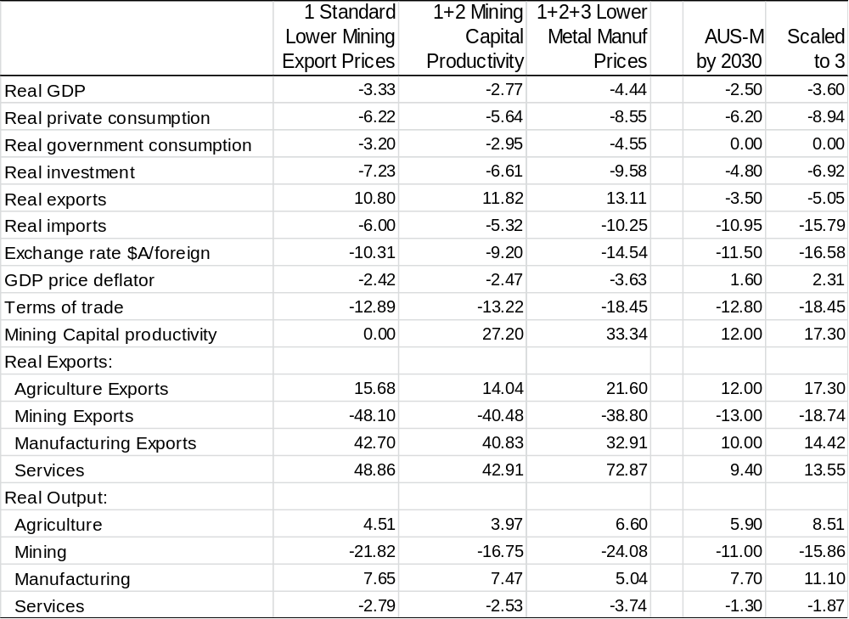
Data Notes: % deviation of variables from baseline. Column one is a shock to mining export prices using the standard long run closure of MMRF. Column 2 adds a shock to mining capital productivity to the shock reported in column 1. Column 3 adds a shock to export prices for steel, alumina, aluminium and other metals (classified as manufacturing exports in MMRF). Column 4 presents the results of a shock to world mining commodity prices (RBA non-rural commodity price index) in AUS-M. Column 5 scales the results in column 4 to be comparable with the MMRF results in column 3.
Data source: Monash MMRF model simulations AUS-M model simulation, author estimates
Results comparison
Perhaps the most surprising aspect of the comparison is that two models with very different approaches to specification and estimation produce broadly similar results. Whereas MMRF is largely calibrated by the model builders in AUS-M all of the elasticities of substitution are estimated directly from the time series data, either as part of demand systems or the joint estimation of production functions. (See also the comparative results in Downes and Hanslow, 2009, which show similar long-run responses across industries to a detailed wage shock.) The fact that both models show similar results is of course no guarantee that they are correct. But it does demonstrate that the results from the model estimated on the basis of the historical time-series data are consistent with patterns we would expect given reasonable elasticities and standard economic theory with optimising households and firms.
However there are some interesting differences in the detail of the results. In particular the exchange rate and income effects in AUS-M lead to a larger import response than in MMRF. Given that the own price elasticities for the import components in AUS-M seem reasonably conservative relative to the literature, this may be because of substitution and income effects leading to higher durable and motor vehicle consumption within the consumption bundle (discussed in the text). But at the same time the response of exports in total is smaller. The response of manufacturing and service exports to the lower exchange rate in MMRF is so large that it more than completely offsets the decline in mining exports so that export volumes in aggregate are 13 per cent higher. (This is interesting in that a comment often made about AUS-M simulation results is that the responses of manufacturing and service exports to a change in the exchange rate seem too large.)
The pattern of results for GDP, household consumption and the exchange rate are similar across the two models as is the pattern on industry output. MMRF has a larger response of mining capital and output, but AUS-M has a larger impact from the exchange rate on manufacturing. (This reflects the larger mining investment response in MMRF requiring manufacturing inputs, and the larger import response in AUS-M implying more crowding out of local manufactures.) In both MMRF and AUS-M agriculture and manufacturing output are higher while services are a little lower. (The services result is roughly proportional to the overall GDP result – perhaps not surprising for industries like distributional services, the margin industries in MMRF, which are largely indifferent to where the goods being distributed come from.)

Appendix 2: Description of AUS-M
AUS-M is essentially an outgrowth of the 1990s version of the Treasury Macroeconomic (TRYM) model. TRYM in turn developed out of the AMPS model developed by the EPAC Secretariat in the 1980s, as did the Murphy model. AMPS, TRYM and the Murphy Model were all models in the Keynes Klein (K-K) tradition with sticky prices and wages and output determined by demand in the short-term. Where they differed from early applied K-K models such as the 1971 Treasury NIF model, was in their response to the Lucas and Sims critiques of the theoretical and econometric underpinnings of these models. Like other models of the 1990s such as the US FRB MPS model, the IMF’s Multi-Mod, the Bank of England’s core macro model, and Warwick McKibbin’s MSG model, they introduced explicit optimisation to the supply side of the model, took greater care in the treatment of expectations, had a derivable steady state solution, and used econometric techniques that took greater note of orders of integration and issues of dynamic consistency (the consistency of short-run dynamics with the long-run steady state). AMPS, TRYM and Murphy treated the financial sector as rational and forward looking, but household and business sectors as adaptive and backward-looking, (although in TRYM there were some elements of forward looking behaviour – for example Q ratios and wealth variables would jump with changes in underlying productivity growth).
Given that the properties of the TRYM model are relatively well known and have been the subject of extensive scrutiny and validation, it is probably useful to focus on the key points of difference between the two models. The main difference is the way in which demand and supply linkages are treated in AUS-M compared with the earlier model. The first section below provides a broad overview of how the industry and commodity detail has been introduced in AUS-M, followed by a short summary of some of the other developments in the model.
Extensive documentation of the TRYM model including background papers is available at:
http://archive.treasury.gov.au/contentitem.asp?NavId=016&ContentID=238

Supply and Demand in AUS-M
AUS-M retains many of the overarching features of TRYM, and has similar macroeconomic properties as a result. (Those in TRYM have been extensively tested, subject to academic and peer review, independently replicated by outside groups, and reconciled with the results from single equation, VAR and other models.) A fiscal or monetary policy change in AUS-M for example gives similar results to the original TRYM model. The main difference is in the wealth of industry, commodity and other detail provided in the results.
Table 2 below shows the supply and demand variables in AUS-M. The way the detail is incorporated, and supply and demand are linked is by utilising information from the input-output tables. To do so with a minimum of complexity the input-output tables are first reduced down to a manageable size by inverting the tables to produce a mapping of supply to demand. This mapping is then used to form up a demand system for the supply side variables (industry output and imports – see Figure 3). A framework similar to the Almost Ideal Demand System is used to model industry and import volumes with each individual supply component depending on: (1) the input output weighted demand term (2) relative prices, (3) the change in total demand and (4) a stochastic time trend to capture effects from changing technology and tastes. More detail on the industry and import demand system is provided in Appendix A.
2 Supply and demand variables in AUS-M
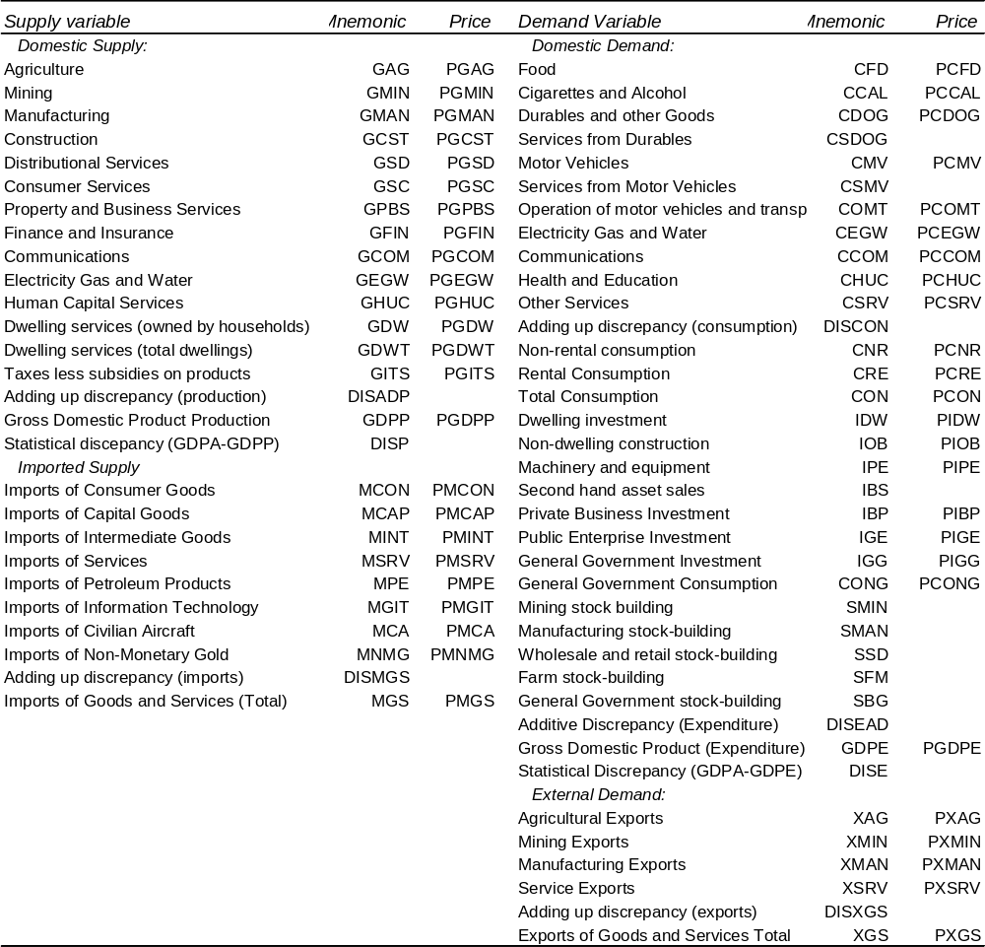Notes: The table shows the main variables. Note that business investment is modelled on an industry basis so that there are investment volume and price variables plus variables for sub-components by asset class for each individual industry. These are aggregated up to produce the investment variables shown.
Data source: Outlook Economics, AUS-M Model Database.
3 Stylised representation of the input-output core of the AUS-M model
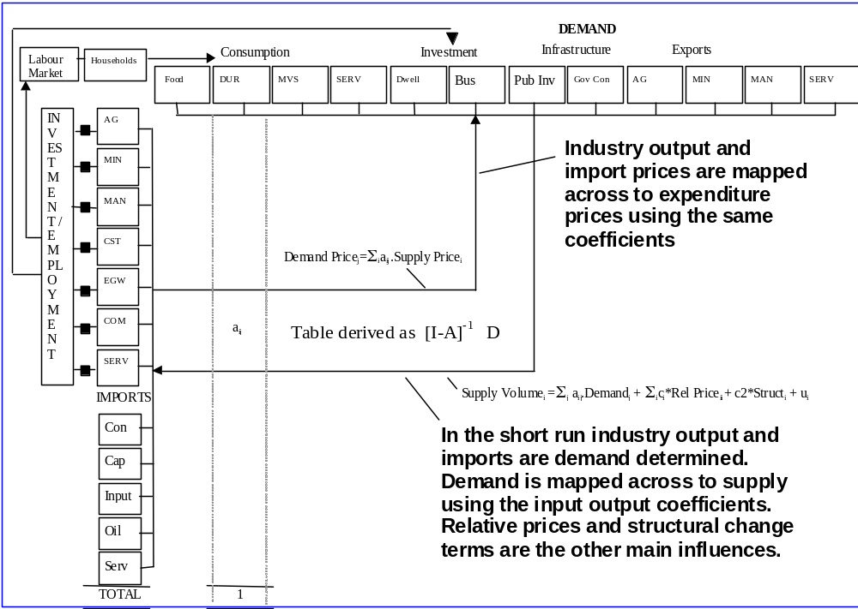
Data source:

The other key elements of AUS-M in addition to those in TRYM are:
- The consumption demand system – to disaggregate household consumption into its component parts. Like the demand system for imports and industry outputs this is based on an almost ideal demand system style framework where each individual component is estimated on the basis of relative prices, the change in total consumption to pick up cyclical and income effects, and stochastic trends to capture changing tastes and technology over time.
- The estimated system of equations for expenditure deflators. This system maps across supply side deflators to the demand-side expenditure items. Each demand side deflator (P.) has an input-output weighted supply side equivalent (PP.). Indirect taxes are also allocated out using the input output coefficients leading to implicit tax variables for each demand component (RT.). Expenditure deflators (P.) respond directly to supply prices (PP.) indirect taxes (RT.) and the GST.
- Disaggregated production function equations – for employment, investment and output prices. The parameters of the production function for each industry are estimated indirectly by jointly estimating equations for employment, investment and output prices. (The long run of each equation depends on the marginal product condition for profit maximization/cost minimizaton and hence the equations contain common parameters.) Stochastic trends capture changes in underlying labour and capital productivity. Each industry has a derived measure of potential output and hence capacity utilization which can be compared with measures from the business surveys.
- Disaggregated trade equations – for import and export prices and export volumes. These involved forming up a range of new trade weighted exchange rates, world prices, and weighted trading partner demand terms.
- Disaggregated equations for inventories. Stock-building is broken down into its component parts (mining, manufacturing, distributional services, agriculture). Each component has a separate measure of sales which is related back to the demand terms for the individual sectors. In the long run inventories return to a level consistent with the equilibrium stocks to sales ratio for each industry.
The model also includes much more detail in a number of other areas with a particular focus on markets that are characterised by search, partial equilibrium and stock-adjustment dynamics. For example:
- The labour market framework includes unfilled job vacancies and a detailed cohort model that forecasts the duration structure of unemployment. The cohort model contains equations for exit rates (from unemployment) which capture turnover effects. As the economy goes into recession, employment turnover falls, exit rates from unemployment fall and long term unemployment increases. As the long term unemployed are less active in job search, this reduces the overall search effectiveness of the unemployed, pushing up the vacancy rate for any given level of unemployment. A decrease in search effectiveness also reduces the impact of any given level of unemployment on wage inflation (i.e. raises the NAWRU).
- Movements in vacancies also impact on labour demand. When the economy is close to or above full employment, increases in labour demand will tend to manifest themselves more in terms of an increase in unfilled vacancies than an increase in employment (reducing the volatility of employment). Employment equations are estimated on an industry basis, and employment demand for each industry is adjusted for unfilled vacancies and for average hours worked for the particular industry.
- The dwelling sector includes an equation for rental vacancies, in turn dependent on demand versus short-term supply. Lower vacancies lead to higher rents. Higher rents lead to higher rental returns, a higher dwelling Q ratio, and a higher level of investment (higher supply). Higher rental prices also lead to a substitution away from the consumption of dwelling services (lower demand). A higher dwelling Q ratio is associated with higher established house prices, leading to higher consumption (via the wealth effect).
- Explicit equations have been developed for non-dwelling construction investment in Finance and Insurance, Property and Business Services and Consumer Services to capture some of the movement in commercial property investment. This involves equations for both vacancies, and investment. Vacancies are largely dependent on industry employment growth relative to the capital stock, feeding back to the incentive to invest, (but with long time-to-build lags). Adjustments are made to the aggregate industry investment equations to account for the consequent cyclical ups and downs. (For example the office building boom bust cycle is mainly reflected in investment in Property and Business Services, and Finance and Insurance.)
- Government budget identities are much more detailed, reflecting the greater detail available in the model to establish various tax bases, and the fact that the model has a complete representation on the income side adding up to GDPI.
Extensive use is made of joint estimation and systems estimation is constructing the model. In one sense the model can be viewed as a kind of Sudoku, utilizing constraints across a number of dimensions to reconcile estimates and fill in a complete picture of how the economy works. Anything on the expenditure side has implications for the production side and the income side, and vice versa, both in volumes and in values. The model forecasts converge on a steady state growth path that essentially stems from a small scale CGE growth model (the steady state version of the model).
Caveat
Like all models, AUS-M is only an approximation of reality and there are a number of limitations which need to be kept in mind. There are many specification choices, places where data is insufficient, or where more detail is required. Human behaviour is not constant and is subject to learning, rationality is bounded, and economic structures and institutions are constantly changing. Economic analysis that involves feedback is complex. Consequently, the model is not meant to be used just in a mechanical way, and results should be interpreted with care. As in the counterfactual simulations in the paper, it will usually require some work to make appropriate adjustments to the model and to consider the linkages and interpret the results. In that sense it is not meant to be a substitute for hard work, but rather and ideally a complement to thoughtful and more detailed analysis.

Appendix C: Limitations to the model based analysis.
Any model analysis is subject to a range of uncertainties. In this case these can be divided into two parts: the uncertainty around the impact of the mining boom on the structure of the economy in the long run; and those around the adjustment path to that long-run or equilibrium. These two parts can be further subdivided. The long run response can be measured in terms of aggregate income and expenditure levels, in turn dependant on productivity, participation and population, and also in terms of the composition of that income and expenditure. The short to medium term response can be broken down into the responses of the agents in the economy, namely households, businesses and governments (including the central bank).

Long-run or equilibrium
There is probably less uncertainty about the long run income and output effects of an increase in the terms of trade, than there is around the short-run responses. If the terms of trade increase by 25 per cent and exports constitute 20 per cent of GDP then national income will be higher by around 5 per cent, even in the absence of an output response. There are further effects as output in the mining sector responds to the higher prices, with resources in the economy moving to the mining sector. There are some uncertainties around that in terms of for example who receives the returns from the higher export prices and the scale of the response of mining investment to the price change. But by and large the overall aggregated effects are fairly well determined or can be worked out with analysis of the detail.
Where there is more doubt is around the distribution and composition of the long-run income and expenditure effects. For example, to what extent increased mining activity crowds out other activity on the supply side of the economy, and to what degree patterns of expenditure and trade change on the demand side. In AUS-M these long-run compositional responses depend on estimated long run own-price and cross-price elasticities of demand in the consumption and industry demand systems and estimated elasticities of substitution in the individual industry production function.

Short to medium run adjustment paths
There are many uncertainties around the short-term adjustment paths in models like AUS-M and in one respect the reason the model exists is to allow users to explore different assumptions about these paths. The uncertainties around the paths of economic variables in contingent scenarios are of a different kind to those around a short term forecast. A short-term forecast largely depends on uncertainty around the exogenous inputs (such as forecasts for commodity prices, world growth, world interest rates various equation residuals etc.). For the scenarios these exogenous inputs are taken as given. Consequently the main uncertainties relate to:
- Firstly the error bands around estimated parameters and coefficients in the models behavioural equations (e.g. the standard error around estimated elasticities of substitution and error correction coefficients)
- Secondly assumptions about the expectations of agents in the model (businesses, households and government) and in particular the extent to which they are assumed to view the shocks as permanent or temporary. Broadly speaking financial markets are assumed to be forward looking, while the behaviour of households and business is assumed to reflect a mixture of forward looking and adaptive behaviour.
For these reasons there is considerable uncertainty around the short-run financial market, business and household reactions. But that said the uncertainty varies depending on the specific linkage being considered. For example we can be very sure that the adjustment of the mining capital stock will require a period of higher investment, and that this higher investment will generate higher demand for construction outputs, but less sure about the exact timing of the investment surge. Similarly we can be sure that persistently higher commodity prices and an expansion of mining output will be favourable to the trade balance and hence lead to a higher equilibrium exchange rate, but less sure about the exact timing and speed of adjustment of the exchange rate. In the counterfactual simulations households initially treat the rise in income due to the mining boom as temporary at least in part, because this is how they have responded to terms of trade increases in history (captured in the coefficients on the commodity price term in the consumption equation). This is consistent with the rise in household saving that has been observed over the last ten years. But there is no way of being absolutely certain that this was the exact cause. If households were treated as more forward looking and knew that the rise in income was permanent, then consumption would rise immediately in anticipation of future income and saving fall. This would then have other consequences – for example the demand for rents would be higher in the short-term leading to even higher rental prices than in the simulation and consequently to a more rapid adjustment of the dwelling capital stock.
Similarly, nearly all of the short-term linkages in the model are subject to uncertainty and open to debate. The important thing is to be aware of the assumptions and specifications behind individual result, not to treat the results as holy writ, and to be able to think about and explore the implications of changing coefficients or specifying key behavioural equations in a different way.

The comparison adjusted for the purchasing power of different currencies over a standardised basket of goods and services, indicates that Australia was the 11th ranked country in 2012 on a GDP per capita basis, behind countries such as the United States, Singapore and Hong Kong, but in front of the United Kingdom. This was an improvement on the ranking from a decade earlier (16th).
The share of global saving due to developing countries reached 51 per cent in 2012, having risen from 20 per cent in 1999. The share due to developing Asia rose from 9 per cent to 30 per cent over the same period. Investment shares follow a similar pattern, (estimates based on IMF WEO Database April 2013).
They distinguish between a terms of trade shock driven by: (1) an increase in world demand; (2) developments in individual commodity markets; and (3) globalisation and the rise of Asia where rising commodity demand and prices are accompanied by lower manufacturing prices. The estimated impacts are markedly different for output, inflation and the exchange rate. This echoes the findings of international modelling exercises (and for example domestic modelling of international linkages using TRYM) , where demand shocks in one country have ambiguous effects on others – the demand shock not only increases demand for imports, but also raises interest rates drawing capital from the other countries. The capital market effects usually dominate the direct trade effects (see McKibbin and Sachs (1991) or Downes and Drew (2003) for a discussion of changing financial market linkages. Unfortunately the VAR doesn’t include interest rates making it a little difficult to determine what role they play in the results.
In particular McKibbin and Cagliarini look at the impact on Australia of a rise in energy and mining commodity prices relative to manufacturing prices driven by: (1) rising productivity in China; (2) a reduction in risk; and (3) monetary easing in the US (which increases flexible prices like commodities relative to prices with more inertia). One surprising result is that an increase in commodity prices driven by an increase in manufacturing productivity in China reduces income and GDP in Australia (by drawing capital away from OECD countries and increasing global real interest rates). The authors note that it is the particular calibration of the shock that contributes to the result. Still it is a useful reminder about how unusual developments in the global economy have been over the last five to ten years, yielding both record high commodity prices and exceptionally low global interest rates.
Arguably low interest rates have been one factor adding to the level of commodity prices (particularly metals) with a lower discount on future expected prices (see also footnote 3).
This is to some extent the flip side of the coin to the rising demand for commodities (which is partly driven by falling prices and hence rising demand for Chinese goods). The larger part however is coming from continuing innovation and quality improvements in electronic goods.
See Downes and Stoeckel (2006, 2009) and Downes and Hanslow (2009) for examples of previous applications of the model. The model has been generating forecasts since 2006 and has a reasonable track record as measured by RMSE across major variables. It performed particularly well following the GFC. (Appendix A to Downes and Hanslow (2009) provides a detailed description of the model outlook at the time – early 2009.)
See also results for the China productivity shock in McKibbin and Cagliarini (2009).
This was also a theme in the earlier Australian debate around the Gregory effect, see Gregory (1976), Stoeckel (1979), Corden and Neary (1982) and Cook and Seiper (1984).
As the equations in AUS-M are estimated on the basis of historical time series data, it is possible to start the model at any point in history back to 1980. Before shocking the model in history a prior simulation is required to check that the model does replicate history. Preparing a historical counterfactual mainly involves checking that all the data, parameters, equations and equation residuals have been transcribed correctly between the estimation files and the model files in Eviews. With 500 equations and around 1500 variables and 2000 parameters and a model that is re-estimated and updated quarterly often with significant revision to historical data, it is easy for small errors to creep in. The counterfactual provides one of a series of tests that the model is functioning as intended. .
Ideally the shocks to the world variables entering into the model would be drawn from a specific shock to a global model (as in Cagliarini and McKibbin, 2009). The assumption in our shock is that global interest rates are unchanged (largely on the basis of the observation that it would be hard for them to have been lower over the period), which implies that lower growth and investment in China is accompanied by lower saving by SOEs and households. (That is the leftward shift in the investment schedule is accompanied by a leftward shift in saving.)
Australian export iron ore prices in US dollars (at 2010-11 constant prices) had declined from $US30 per ton in 1990 to $US19 per ton in 2002
BREE, 2013, P.10, 16.
As mentioned the other coincident factor was the fall in global interest rates and the availability of capital. The model incorporates the effect of lower global interest rates, i.e does not require special adjustment. The assumption is that interest rates would also have been low in the absence of higher growth in China.
Mining output in the model is defined as constant price value added rather than gross product. The relative capital intensity of LNG production means that it has a lower output to capital ratio for a given rate of return.
Connolly and Osmond, 2011, P.40. They argue that adjusting for the imported content of domestic expenditure in the company level data would probably take the import share of mining investment up to around 50 per cent.
Gregory and Sheehan, 2012, P.10 – based on assumptions about import content per project and a gradual increase in import content over time due to the high dollar.
Equations for capital goods imports and construction output are estimated jointly as part of a system of equations that link demand to supply. Part of the system involves mapping components of demand to components of supply using information from the input output tables. If non dwelling construction has an unusually high import content relative to history, then the system will tend to underestimate capital goods imports and overestimate construction activity.
Residuals are adjusted from 2010 quarter three onwards with the deviation in mining investment counterfactual to actual used as a guide to the size of the adjustment. The adjustment to the construction output residual is scaled at 0.625 of the capital good import residual adjustment.
The 1990s version TRYM (Treasury Macroeconomic Model) was subject to extensive review during its lifetime, both internally and by external academic reviewers. The model and its responses were independently replicated by outside researchers. It was shown to have macroeconomic responses that were similar to the Pagan Dungey 10 equation VAR model of the Australian economy and the RBA small model.
In the long run the exchange rate has to move to a level which reconciles the trade balance with the savings and investment balance in turn dependent on decisions by households business and government. For a discussion of the inclusion of uncovered interest parity and commodity prices in a model containing a steady state see Douglas and Downes (1997)
Also the wage equation contains the RBA inflation target as an anchor for inflation expectations and there is a question of whether the coefficient on this has increased over time. If there is a negative exogenous shock that raises unemployment, then greater anchoring means less deflation and a slower return to equilibrium.
Once unemployment and interest rates return to equilibrium the dwelling stock falls below baseline, so by 2030 consumption of rents do fall below baseline
Income from overseas mining assets has similar characteristics to domestic mining assets. As commodity prices are set in global markets the $A income derived is independent of the location. The only difference is the greater diversity of exposure to different commodities. The important thing from an Australian investment income point of view isn’t the level of Australian ownership of domestic resource projects, but the share of resource holdings in total wealth.
Valuation of the resource asset is difficult. In the ABS national balance sheets sub-soil assets are attributed to the government sector, and accumulated exploration expenditure is allocated to the mining sector. But as Topp et. al, 2008, argue this is likely to understate the importance of the resource in production. During a period when there has been a structural shift in commodity values it seems likely that the ABS methodology significantly understates the asset value in terms of legal rights over tenements and leases attributable to the mining sector.
Note that the net rate of return for mining shown in Chart 18 is net of taxes less subsidies on production, which includes state mining royalties, but not taxes on income such as the petroleum resource rent tax (PRRT) and the minerals resource rent tax (MRRT). The PRRT which also covers LNG projects is projected to raise $2.6 billion in 2015-26 and $2.7 billion in 2016-17.
See Mercereau, 2005, P 30 for example.
If mining investment had been exclusively developed by Australian investors funded by foreign currency borrowing, prospective income flows from mining exports would be higher, but so would the countries exposure to a downturn in commodity prices. Not only would incomes fall but the resultant depreciation would also leave Australia with higher debts / a capital loss on the borrowing.
In the ten years to 2004, the decade prior to the mining boom, real per capita consumption had grown by 32 per cent. Incomes in this period were boosted by high productivity growth stemming from micro-economic reform, and the recovery from the 1991-92 recession.
Parnham (2012) provides evidence on the reasons for the slow-down in productivity growth.
Consumer confidence levels over the last ten years (excluding the GFC) have been lower than in the 10 years prior to 2004.
For example tourism and air transport services are very price competitive.
It is interesting to speculate that if manufacturing was better integrated into world production chains and Asian markets it would be more advantaged by the pick-up in world demand that has driven commodity prices higher. The growth in Asian markets presents an opportunity to manufacturers as well as a competitive threat.
For this the model employs a system very similar to that outlined by Rayner and Joyner, (2013).
The substitution effects depend upon a set of estimated cross price elasticities from a set of jointly estimated equations which bears some similarities to the almost ideal demand system of Deaton and Muelbauer (1980) in that the dependent variables are the weights in total supply, cross price elasticities are symmetric, and income and substitution effects sum to zero.
So for example a car manufacturer has a smaller share of the market meaning a smaller production run leading to a higher cost for each car. Note though that underlying productivity is assumed to be unchanged, i.e. the scenario does not allow for increased innovation or compositional change within manufacturing driven for example by opportunities in the growing Asian market.
The decline in the share of manufacturing in total output is something that has occurred across OECD countries as a result of a combination of the Baumol-Bowen effect and a shift in final demand toward services, see Giesecke (2004), Downes and Stoeckel (2006) and Minifie 2013, particularly Chart 3.4, something that is often misattributed to trade. For most OECD countries an increase in manufacturing imports has been accompanied by increased manufacturing exports with little change in net trade but large changes in composition.
Or put a different way, output prices and profits are lower as a result of the mining boom leading firms to cut labour costs for a given level of output.
For example it is relatively easy to generate a recession scenario around the current outlook if there is a substantial short term fall in commodity prices, an increase in risk perceptions, but no change in the exchange rate (for example because of flight to safety of international capital).
The increased sensitivity of the terms of trade to commodity prices means that in the model’s steady state a larger change is required in the exchange rate to reconcile the national savings investment balance with the trade balance and the current account balance. Or in short, the exchange rate needs to be more responsive to any given commodity price movement (assuming that movement is expected to persist). This is accommodated in the model by having a time varying parameter on the world mineral commodity price in the exchange rate equation.
Spot prices for bulk commodities have little necessary relation to future prices, and it is the markets expectation of future prices and trading conditions that is important for the exchange rate. In theory the exchange rate should only respond to the degree that market participants perceive a change in commodity prices to be permanent. Spot prices of high value metals that can be easily stored in warehouses will move in tandem (usually in contango) with the future price. But the same cannot be said of bulk commodity prices where spot prices do not necessarily reflect market expectations for the future course of prices. Bulk commodity prices now make the largest contribution to the terms of trade and hence there is no reason for an exact relation between the terms of trade and the spot exchange rate. The equilibrium impact of a permanent change in bulk commodity prices could be larger insofar as the supply response is larger than for metals.
Adding to this but unrelated to the mining boom, service exports have become less exchange rate sensitive with the decline of transport services and rise of education exports.
Arguably higher uncertainty or expected volatility should also lead to higher hurdle rates further reducing the effect of a given change in interest rates.
So the counterfactual has some similarities to a combination of Beans’ North Sea Oil resource discovery and second oil price shock results.
The increased labour mobility is due to improved mutual inter-state recognition of trade qualifications.
Applied uniformly across export categories.
Real consumer wages rise by 4.7 per cent for Tradespersons and 6.3 per cent for Intermediate Production and Transport Workers.
Reduced labour mobility is implemented by setting inter-state labour mobility at zero for occupational categories without mutual recognition – i.e. fixing the labour supply for these occupational categories at the regional level. (In normal simulations labour supply by occupation is fixed at the national level but allowed to move freely between industries and regions.)
The short run results are similar to the Treasury results, the main differences arising from the different pattern of export price shocks imposed.
The shock is calibrated according to the pattern on price changes across merchandise exports and imports from 2006q2 to 2010q4, and designed to produce a 20 per cent increase in the aggregate export price index, and a 10 per cent decrease in the import price index, TMJ, P.139.
Agricultural employment is also slightly higher. The shock on the export side includes an increase in agricultural export prices consistent with that observed between 2006 and 2010.
As there are still some cyclical movement in the data the average deviations over the period 2025:3 to 2030:2 are reported in Table A1.
The simulation explicitly includes an equation linking capital productivity to output levels for mining sectors. The capital productivity adjustments are calculated by applying per cent changes in capital productivity to the rental value of capital stocks.
The simulation was performed by shifting the export demand curves for steel, alumina, aluminium and other metals inwards relative to the previous simulation.
Both models use CES production technology for industry value added and are based on ABS input output data. The AUS-M production functions model constant price industry value added while MMRF models industry gross output using a nested CES structure at a much higher level of detail. (Some inputs are combined in fixed proportions at the top level of the nested production functions for some industries but substitution allowed elsewhere.) The treatment of trade is broadly similar. There are significant differences in the labour market specifications but these mainly affect the short term dynamics not the long run results. (See discussion in Downes and Hanslow, 2009.)
Note that the simulation here does not include the skewing of mining investment towards capital goods imports and away from construction which was part of the historical counterfactual. If it were included the contrast with MMRF would be larger.)
See Taplin et al 1993 on the TRYM model and Murphy et al 1986 on the AMPS model.
This table is known as the Primary Input Content of Final Demand. If: I is the identity matrix; A the matrix of industry to industry interactions; and D the matrix of industry to final demand coefficients, then the table is given by [I-A]⁻¹D (i.e. the Leontief inverse times the final demand component of the supply-use tables). As the ABS national accounts produce chain-linked, constant-price, time-series estimates of industry value added we are mainly interested in the allocation of value added to final demands (and vice versa) thus avoiding much of the detail of a full blown CGE model. To build an econometric time-series model consistent with the historical data we need to focus on the available time series data. There is no available time series data for the thousands and thousands of industry to industry interactions. Hence we solve out for the industry to industry interactions and model them in a reduced form way by forming up a demand system for individual industry output, that depend on relative prices and the allocation out of demand items. That is, rather than impose a set of industry to industry substitution effects by calibrating an extremely detailed set of equations based on data we don’t have, we let those effects be determined by the responses to relative prices evident in the historical time series data.
Deaton and Muelbauer, 1992.
The logos ergos or hard speech as Aristotle put it (as opposed to the logos argos or lazy speech of the sophists – the ancient world’s equivalent of lawyers and public advocates).
The 5 per cent is measured in real terms. There are a number of variations in terms of the formulae that can be used for the direct calculation. (Gregory, 2011, provides a survey. See also ABS, Cat No 5206.0, explanatory notes and background papers in issues 2004q3 and 2001q4.) Ultimately the welfare effect depends on the impact on real household incomes and hence consumption over time.
For a more extensive discussion along these lines see Chapter 6 in The Macroeconomics of the TRYM Model of the Australian Economy, Commonwealth Treasury, 1996. http://archive.treasury.gov.au/contentitem.asp?NavId=016&ContentID=238

